OASIS ME

ENHANCED WEB-BASED AVATAR CUSTOMIZATION BEYOND READY PLAYER ME

Treball Fi de Grau de

Javier Portabella Clariana

Directora: Eva Valls Garolera

Grau en Enginyeria en Sistemes Audiovisuals

Curs 2024-2025



Dedicatòria [opcional] [mida 12]

Lorem ipsum

**Agraïments**

Lorem ipsum dolor sit amet, consectetur adipisici elit, sed eiusmod tempor incidunt ut labore et dolore magna aliqua. Ut enim ad minim veniam, quis nostrud exercitation ullamco laboris nisi ut aliquid ex ea commodi consequat. Quis aute iure reprehenderit in voluptate velit esse cillum dolore eu fugiat nulla pariatur. Excepteur sint obcaecat cupiditat non proident, sunt in culpa qui officia deserunt mollit anim id est laborum.

Lorem ipsum dolor sit amet, consectetur adipisici elit, sed eiusmod tempor incidunt ut labore et dolore magna aliqua. Ut enim ad minim veniam, quis nostrud exercitation ullamco laboris nisi ut aliquid ex ea commodi consequat. Quis aute iure reprehenderit in voluptate velit esse cillum dolore eu fugiat nulla pariatur. Excepteur sint obcaecat cupiditat non proident, sunt in culpa qui officia deserunt mollit anim id est laborum.Lorem ipsum dolor sit amet, consectetur adipisici elit, sed eiusmod tempor incidunt ut labore et dolore magna aliqua. Ut enim ad minim veniam, quis nostrud exercitation ullamco laboris nisi ut aliquid ex ea commodi consequat. Quis aute iure reprehenderit in voluptate velit esse cillum dolore eu fugiat nulla pariatur. Excepteur sint obcaecat cupiditat non proident, sunt in culpa qui officia deserunt mollit anim id est laborum.

Lorem ipsum dolor sit amet, consectetur adipisici elit, sed eiusmod tempor incidunt ut labore et dolore magna aliqua. Ut enim ad minim veniam, quis nostrud exercitation ullamco laboris nisi ut aliquid ex ea commodi consequat. Quis aute iure reprehenderit in voluptate velit esse cillum dolore eu fugiat nulla pariatur. Excepteur sint obcaecat cupiditat non proident, sunt in culpa qui officia deserunt mollit anim id est laborum.

**Abstract**

This project focuses on the development of an interactive web interface for 3D avatar customization. The tool combines concepts present in existing platforms: it offers the accessibility and ease of use of Ready Player Me, along with an advanced facial feature interpolation system inspired by the MetaHuman Creator’s approach. To achieve this, a Voronoi cell-based technique has been used to interpolate between multiple facial models intuitively and in real time.

In addition to interpolation, the system includes features such as texture recoloring and the application of wrinkles to simulate aging. These customization options try to allow the creation of more diverse and representative characters.

This document begins by presenting all the theoretical foundations required to develop the interface. Additionally, the general design proposal for the interface and its evaluation method are presented. Followed by a state-of-the-art review and a detailed explanation of the development process, including key challenges and solutions.

By analyzing these elements, the document provides an overview of the project: its objectives, design, implementation, and results.

**Resum**

Aquest projecte se centra en el desenvolupament d'una interfície web interactiva per a la personalització d'avatars en 3D. L'eina combina conceptes presents en plataformes existents: ofereix l'accessibilitat i la facilitat d'ús de Ready Player Me, juntament amb un sistema avançat d'interpolació de trets facials inspirat en l'enfocament de MetaHuman Creator. Per aconseguir-ho, s'ha utilitzat una tècnica basada en cel·les de Voronoi per interpolar entre múltiples models facials de manera intuïtiva i en temps real.

A més de la interpolació, el sistema inclou funcions com ara la recoloració de textures i l'aplicació d'arrugues per simular l'envelliment. Aquestes opcions de personalització intenten permetre la creació de personatges més diversos i representatius.

Aquest document comença presentant tots els fonaments teòrics necessaris per desenvolupar la interfície. A més, es presenta la proposta de disseny general de la interfície i el seu mètode d'avaluació. A continuació, es fa una revisió de l'estat de la tècnica i una explicació detallada del procés de desenvolupament, incloent-hi els reptes i les solucions clau.

Analitzant aquests elements, el document ofereix una visió general del projecte: els seus objectius, disseny, implementació i resultats.

**Resumen**

Este proyecto se centra en el desarrollo de una interfaz web interactiva para la personalización de avatares 3D. La herramienta combina conceptos presentes en plataformas existentes: ofrece la accesibilidad y facilidad de uso de Ready Player Me, junto con un sistema avanzado de interpolación de rasgos faciales inspirado en el enfoque de MetaHuman Creator. Para lograrlo, se ha utilizado una técnica basada en células de Voronoi para interpolar entre múltiples modelos faciales de forma intuitiva y en tiempo real.

Además de la interpolación, el sistema incluye funciones como la recoloración de texturas y la aplicación de arrugas para simular el envejecimiento. Estas opciones de personalización buscan permitir la creación de personajes más diversos y representativos.

Este documento comienza presentando todos los fundamentos teóricos necesarios para el desarrollo de la interfaz. Además, se presenta la propuesta general de diseño de la interfaz y su método de evaluación. A continuación, se presenta una revisión del estado del arte y una explicación detallada del proceso de desarrollo, incluyendo los principales retos y soluciones.

Mediante el análisis de estos elementos, el documento ofrece una visión general del proyecto: sus objetivos, diseño, implementación y resultados.

**Contents**

Introduction 1

1.1 Motivation 1

1.2 Objectives 2

Theoretical Foundations 3

2.1 Fundamentals of 3D Modeling 3

Polygons and Vertices 3

Meshes 3

Materials 4

UV Mapping 5

2.2 Morph Targets and Texture Mapping in 3D 5

Morphing 5

Multi-character Morphing 5

2.3 Overview of Relevant Technologies 6

Three.js 7

State of the Art 8

3.1 Overview of Web-based Applications for 3D Modeling 8

3.2 Review of existing 3D Character Creators 10

MetaHuman Creator 10

Ready Player Me (RPM) 11

3.3 Other Avatar Customization Areas: Social Media and Video Games 12

3.4 Comparison of RPM, MetaHuman Creator and others 13

3.5 Dynamic Mesh Morphing 14

Design and Methodology 16

4.1 Principles of User Interface Design for 3D Applications 16

4.2 Initial layout 16

Implementation Process 19

4.1 Environment Setup and Data Preparation 19

4.2 Avatar Rendering and Interface Architecture 20

4.3 Morph Targets and Interpolation 21

4.4 Customization Tools and Advanced Features 22

Results 25

6.1 Final Interface Description and User Flow 25

6.2 Analysis of Avatar Customization 26

6.3 User Tests Results 28

Conclusions 29

7.1 Future Work 29

Bibliography 31

Appendix A

**Chapter 1**

# Introduction

The fast growth of immersive technologies and interactive media has led to more and more users becoming interested in the creation of personalized and realistic three-dimensional characters. The customization of 3D avatars is becoming essential in some fields like gaming, virtual reality (VR), social platforms, and more. This demand was what made me innovate to make it more accessible with a web interface.

This project focuses precisely on this. It takes advantage of the innovation opportunity presented and develops a web application for creating customizable 3D characters. It will extend the functionality of the API provided by **Ready Player Me (RPM)**[1]. RPM is a platform where each user can create its own avatar by choosing between prebuilt assets such as 3D face and body meshes and modifying them in infinite ways, enabling developers to integrate avatar creation into various platforms. However, its customization capabilities are limited, particularly for users seeking advanced features like detailed facial modifications, complex aging effects, or some hair personalization. A more extensive explanation of this is done in section 3.2.

To overcome these improvements, this project will design a user-friendly web interface that allows users to interactively customize avatars with intuitive controls. Also, it will introduce new customization options, such as facial feature interpolation, wrinkle texture application for aging effects, and recoloring options.

It also builds upon the final degree project by Oriol Jiménez Ayguadé[2], a Computer Engineering graduate. Our projects have similar approaches and goals, so I have been able to adapt his work to achieve higher-quality avatars and improve scalability. This is because the user will be able to choose from a wider variety of avatars to use as templates, so that a better representation of themself can be done.

The project's implementation will focus on two core areas:

1. **User interface development**: making sure the user interaction is an accessible, fluid, and intuitive customization process.
2. **Algorithmic innovation**: improving the interpolation of morph targets, application of new textures and modification of the preset ones.

## 1.1 Motivation

When the opportunity came up to focus my final degree project on 3D avatar customization, one of the first things that came to mind was the film *Ready Player One*[3]. This movie left a lasting impression on me from the moment I watched it upon its release in 2018. The story follows Wade Owen Watts, a young gamer from the year 2045 who, like the rest of humanity, finds solace in the OASIS virtual reality metaverse, preferring it over an increasingly bleak real world. In OASIS, everyone can have an avatar that represents them exactly how they wish to be seen.

The idea of a completely customizable virtual identity was what most impressed me about Ready Player One. Although the movie is, at its core, a critique of society, I was captivated by the idea that everyone could have a personalized virtual version of themselves, shaped entirely by their own choices and imagination. This notion of freedom through the customization and design of the characters, where the only impediment is our imagination, is what inspires the vision for this project. The goal is to bring a slice of this fictional concept into reality by granting users this freedom to design their own 3D avatars.

## 1.2 Objectives

The main goal of this project is to build a web application that lets users design, customize, and download their own 3D avatars. Many video games, social platforms, and virtual space creation tools use external APIs to integrate avatars into their interfaces. This project aims to offer a similar service, focusing on the creation and customization of avatars, which can then be easily integrated into a wide range of applications. A series of goals have been set out to facilitate this transition:

* **New customization options**: The app will have features beyond what the Ready Player Me (RPM) interface offers. Users will be able to interpolate between facial traits from several avatars to produce a new one, add ageing effects like wrinkles or grey hair and adjust other characteristics such skin tone, eye color, clothing, and more.
* **User-friendly design**: A key aspect of this project is making a simple and intuitive interface. So that, even those with no experience in 3D modeling, can easily navigate the application while keeping it accessible and straightforward.
* **Avatar export options**: Users will have the possibility to download their final creations in formats that work with other platforms, enhancing the app's utility and versatility.
* **Improved performance and accessibility**: The platform will be web-based and lightweight, unlike heavier tools like Metahuman Creator, ensuring a smooth experience even on less powerful devices.
* **Diverse representation**: greater inclusivity is sought, offering customization options with a variety of skin tones, facial structures, genders, and styles.

With these objectives in mind, the project aims to blend customization creativity with technical ease, providing a practical tool that makes avatar customization more accessible to global users.

**Chapter 2**

# Theoretical Foundations

This section focuses on providing the theoretical foundations of the work. It is about explaining the fundamental concepts, basic technologies, and scientific or technical principles that will be used in the project. Here, the essential information that serves as a foundation for understanding the problem and the available tools is introduced.

## 2.1 Fundamentals of 3D Modeling

The process of 3D modeling consists of the creation of three-dimensional representations of objects using specialized computer software. In traditional modeling, 3D objects are created using surface representations such as polygonal meshes, NURBS patches[1] or subdivision surfaces.

### Polygons and Vertices

Polygons are the fundamental building blocks of 3D models, forming the surfaces that define an object’s shape. A polygon is a flat, two-dimensional shape composed of straight edges (edges) and corners (vertices). The simplest polygon is a triangle, consisting of three vertices and three edges. More complex polygons, such as quadrangles (quads) or n-gons (polygons with more than four sides), can also be used, but triangles are the most common due to their stability in rendering and computational efficiency.

Vertices are the most basic elements in a 3D mesh. Each vertex represents a single point in 3D space, defined by its coordinates (X, Y, Z). These points serve as the foundation for constructing edges and faces, ultimately shaping the model.

The number of polygons in a model (polycount) affects both performance and visual quality:

* Low-poly models: Use fewer polygons, making them efficient for real-time applications (e.g., mobile games, VR).
* High-poly models: Contain dense geometry for fine details, often used in pre-rendered scenes (e.g., films, high-end visualizations). A well-optimized model balances detail and performance by strategically distributing polygons where needed (e.g., more on facial features, fewer on flat surfaces).

### Meshes

A mesh is a collection of vertices, edges, and faces that define the shape of a 3D object. These three elements are clearly represented in Figure 2.1. To begin with, vertices are the most basic elements of a mesh from which we can obtain the others. It is a set of single points or positions in 3D space that are stored in arrays of coordinates, each array generally representing an object.

Secondly, there are the edges, which are the straight lines connecting two vertices. They are usually invisible on the rendered image, however, in the wireframe view, the edges are seen as “wires” connecting dots and creating the mesh.

Finally, the faces are the flat surfaces enclosed by edges, typically forming triangles, quadrangles or n-gons. They are what is seen when rendering the mesh. If an area between n vertices does not contain a face, it will simply be transparent or nonexistent in the rendered image.

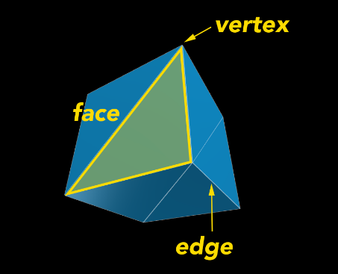

Figure 2.1: Representation of vertices, edges and faces of a cube.

In order to help shade a mesh (among other things), it is very common to use normals. These elements are defined as the perpendicular direction to a face, which, depending on the angle it forms with the direction of the light source, is shaded more or less. These normals will also be interpolated with those of the target avatar to achieve a smooth shading transition between facial parts.

### Materials

In computer graphics, materials define how a 3D object's surface interacts with light, determining its visual properties like color, shininess, transparency, and texture. While the mesh provides the object's shape, the material controls whether it appears matte, glossy, metallic, or translucent by simulating real-world physics (e.g., reflections, roughness, or light scattering).

Textures, which are images mapped onto materials, add fine details like scratches or patterns, but the material itself dictates how those textures respond to lighting. Together, materials and textures transform basic geometry into realistic or stylized surfaces, from dull stone to reflective metal, enabling lifelike or artistic visuals in 3D Modeling. Some examples of these types of materials include those shown at Figure 2.2:

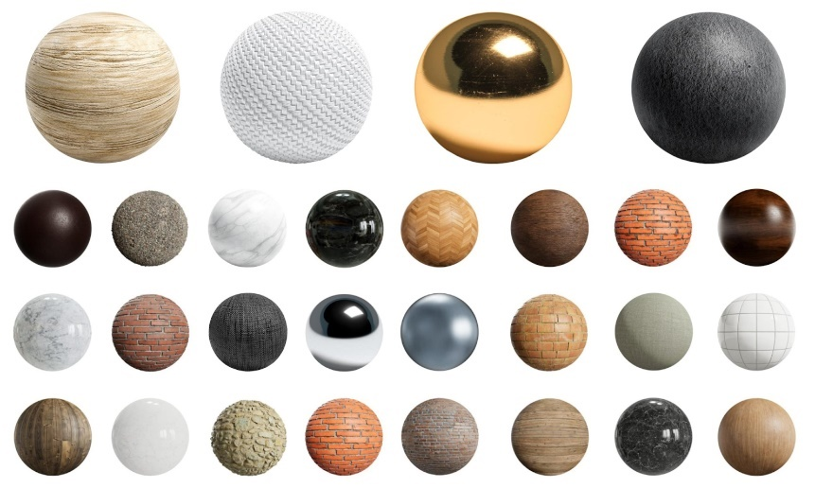

Figure 2.2: Sphere with different textures and materials.

### UV Mapping

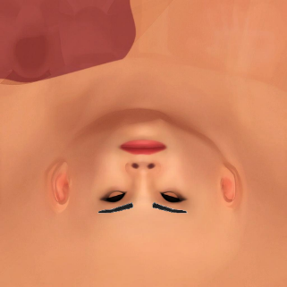UV mapping is the process of deploying a 3D mesh onto a 2D surface, called a UV map, which allows textures to be assigned to points on the model with precision. Each vertex of the model corresponds to a UV coordinate that indicates which part of the image (or texture) is projected onto its surface.

Figure 2.3: Texture used in this project.

This system has been especially useful in my project for applying masks and texture changes, as well as color filters (texture in Figure 2.3 serves as a base texture to apply color filters on it). UV mapping allows for precise adjustments in texture properties, making it easier to apply and modify color filters.

## 2.2 Morph Targets and Texture Mapping in 3D

This section explores two essential techniques in 3D modeling: morph targets (also known as blend shapes) and texture mapping. Morph targets enable smooth deformations of a mesh, while texture mapping enhances surface details without increasing geometric complexity.

### Morphing

Morphing is a 3D animation technique that smoothly transitions between different shapes of a model by directly manipulating its vertices—unlike skeletal animation, which uses a bone rig. It's especially useful for subtle effects like facial expressions, offering fine control over individual features.

The process involves storing multiple versions (morph targets or blend shapes) of a base mesh, each representing a specific deformation—like a smile or frown. Animators blend these shapes using weight values to create smooth, expressive movements. For example, increasing the weight of a "smile" target transitions a neutral face into a grin.

In this project, morphing is applied not between different versions of the same base mesh, but between corresponding parts of two distinct 3D models. The weight values of the targets are determined by the position of a slider in the interface.

### Multi-character Morphing

In this project, when talking about morph targets, we do not refer to different facial expressions of the same character, but to distinct facial features such as noses, eyes, ears, among others; taken from other available characters. These features can be blended in real time to create a new character with unique facial traits. Figure 2.4 shows a simplified example where 70% of a "nose1" morph target is combined with 30% of "nose2" to produce a new intermediate shape. In this example the interpolation is done with the same character and two different noses, which serve as morph targets, but we will be doing the same with different avatars in this project.

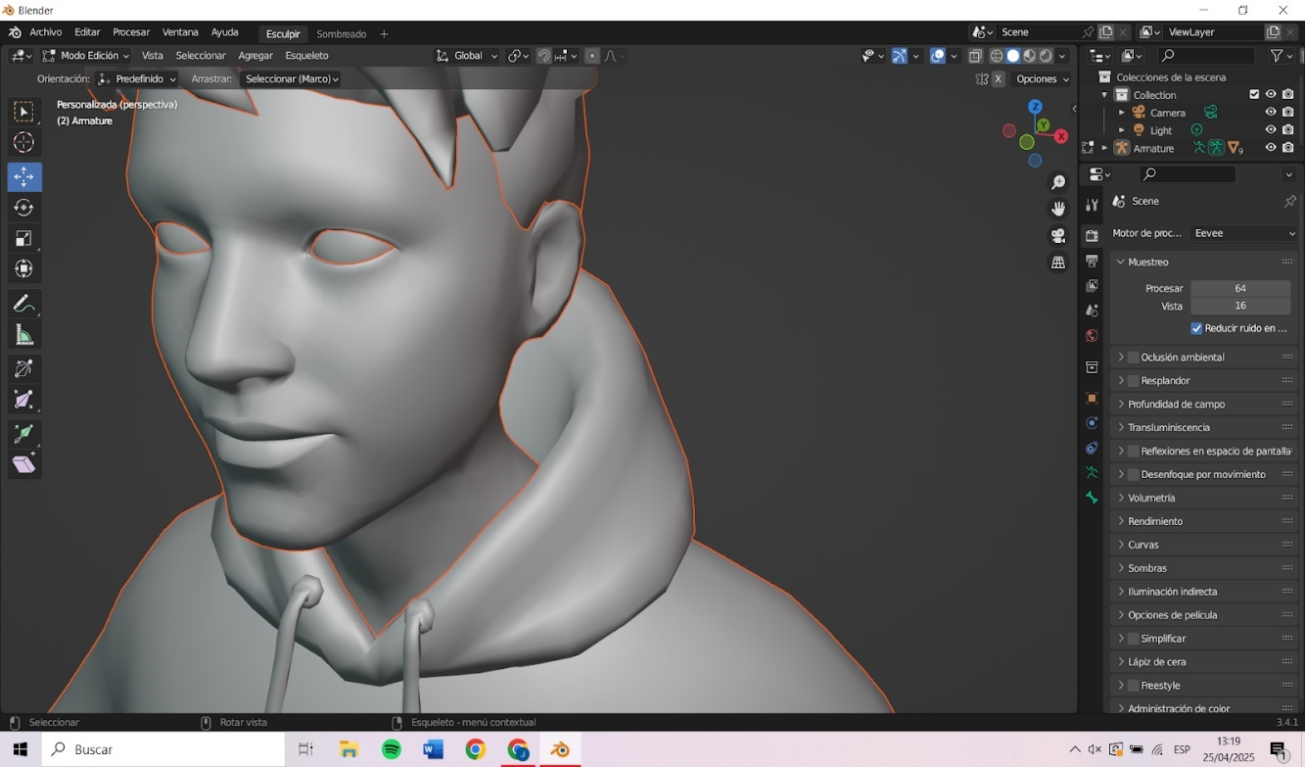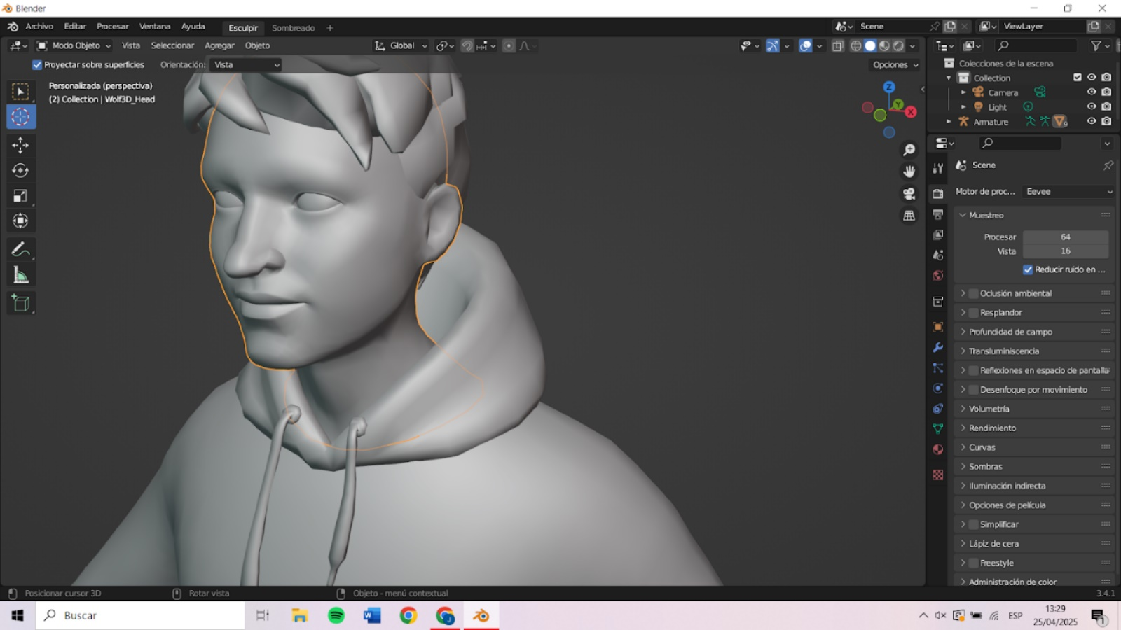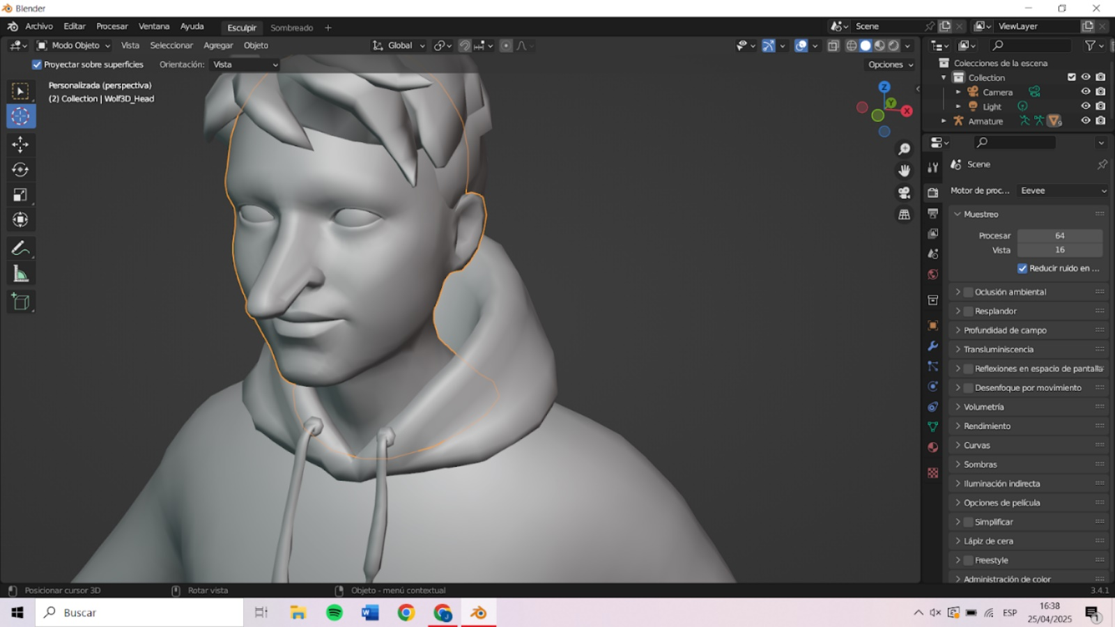

*Figure 2.4: Two morph targets (left and middle) blended to produce a new facial feature (right).*

To perform this type of interpolation, in this project we will calculate the positional difference between the corresponding vertices of two avatars. That is, for each vertex of the source and target models, the system will first calculate the relative position of that vertex with respect to the mesh’s center. Using this relative position of both sets, the difference will be computed vertex by vertex and accumulated in a "delta" variable. By multiplying this delta by a weight before adding it to the source model, we achieve a smoothly adjustable transition between the source and target.

This method avoids global displacements and focuses purely on shape transformation. Without it, blending a tall avatar with a shorter one would incorrectly shift facial parts to match absolute positions rather than their proportions.

The final formula for obtaining the interpolated vertex position is:

$${VtxPos}_{final}={VtxPos}_{source}+α∙\left|{VtxPosCentered}_{target}-{VtxPosCentered}_{source}\right|$$

Where $α$ is the interpolation weight, ${VtxPos}_{source}$ is the original position in the source mesh and the two variables $VtxPosCentered$ are the positions relative to their mesh centers.

This technique can present limitations in other contexts. First, creating morphable meshes eliminates any possibility to modify the mesh structure, like adding or removing vertices, or it will break compatibility. Second, since each morph target is a full mesh, storing many of them increases memory usage. Lastly, transitions between very different shapes may produce unnatural results.

However, these issues will not greatly affect our project. Ready Player Me avatars, even if they could look different at first glance, are designed with the same number of vertices and a consistent vertex order across all models.

## 2.3 Overview of Relevant Technologies

In order to implement interactive 3D applications in web environments, first we need to go through the technologies that support rendering and real-time interaction. Web-based 3D graphics rely mainly on WebGL[2], however, using it directly can be complex and time-consuming. For this reason, high-level libraries such as Three.js or Babylon.js have emerged to simplify the process of building and managing 3D scenes. This section provides an overview of how these technologies enable user-friendly and interactive avatar customization interfaces.

### Three.js

Three.js [10] is a high-level JavaScript library designed to simplify the development of 3D graphics in the browser. Through a well-structured API, developers can create complex 3D scenes that include objects, lights, cameras, animations, and interactions; which are essential components for applications such as avatar customization and facial morphing.

As said above, WebGL is the underlying technology used to render 3D graphics in the browser, but it requires a deep understanding of graphics programming and a significant amount of code to produce even simple scenes. Three.js acts as an abstraction layer over WebGL, saving developers the work of writing complex code and allowing them to focus on design and interaction logic.

Compared to other libraries like Babylon.js, which is more focused on high-performance game development, Three.js offers a simpler API that is ideal for web-based tools requiring high-quality visuals and usability, as discussed in the previous sections.

**Chapter 3**

# State of the Art

This section explores current tools and technologies for 3D avatar creation, focusing on web-based solutions. There is a comparison of major platforms in terms of visual quality, customization flexibility, and accessibility. Special attention is given to MetaHuman Creator [13] and Ready Player Me [1]. This review shows the new features my project aims to address with enhanced in-browser editing and interpolation.

## 3.1 Overview of Web-based Applications for 3D Modeling

Web-based 3D modeling tools have matured significantly in recent years. Early attempts like Clara.io [14] demonstrated that full-featured 3D design and rendering could run entirely in a browser. Today a range of online tools exist, from simple educational editors to complex sculpting suites.

However, these general-purpose modelers typically lack the specialized controls needed for intuitive avatar creation. For example, TinkerCAD [15] is a beginner-oriented web app that lets users build models out of primitive shapes. It is highly restricted to basic geometry and cannot produce organic forms: as one user notes, it is “limited to simple geometric shapes” and cannot create a convincing human face. TinkerCAD also offers no surface texturing or UV mapping – colors can only be applied to whole blocks, not detailed skin or wrinkles.

* **TinkerCAD** (Autodesk): An easy drag-and-drop editor for beginners. It excels at blocky, mechanical models (using boxes, cylinders, among others) as seen in Figure 3.1, but *cannot* sculpt natural forms or fine features. It has no UV textures or material maps, only solid colors. In practice this means TinkerCAD can’t create a realistic head or facial details, making it unsuitable for avatar customization beyond toy-like figures.

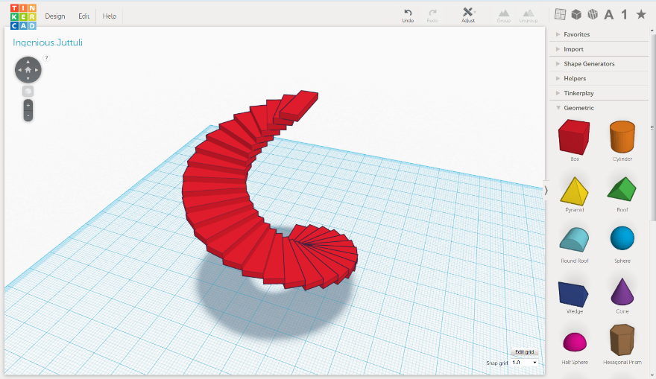

*Figure 3.1: TinkerCAD interface.*

* **SculptGL** (Stéphane Ginier) [16]: A web-based sculpting application offering advanced brushes and dynamic topology. SculptGL provides many modeling tools (like brush, inflate, smooth, grab or twist) and even vertex painting (represented in Figure 3.2), allowing freeform organic modeling in the browser. In contrast to TinkerCAD’s block approach, SculptGL can carve and refine complex shapes. However, it’s essentially a digital analog sculpting studio (like a lightweight Blender sculpt mode), so it relies on the user’s skill; there are no high-level “nose slider” or “face width slider” controls. In short, SculptGL can form faces, but only through manual sculpting rather than intuitive parameter tweaking.

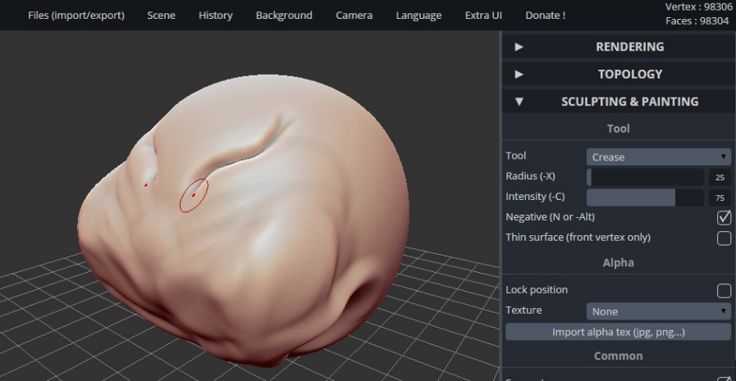

*Figure 3.2: SculptGL interface.*

* **Clara.io** (Exocortex): A once-promising professional website for modeling, animation and rendering. It offered a full desktop-like interface in-browser, as seen in Figure 3.3, with features like sub-object mesh editing, skeletal animation, and integrated V-Ray rendering. Clara.io could import/export many formats and even allowed photo-realistic cloud rendering. However, it was not specialized for character creation, and being very powerful made it complex and resource-hungry. (In fact, Clara.io was shut down in 2022, partly due to the limitations of running such heavy tools in a browser). Its general modeling workflow is far more complex than the slider-based controls our project envisions.

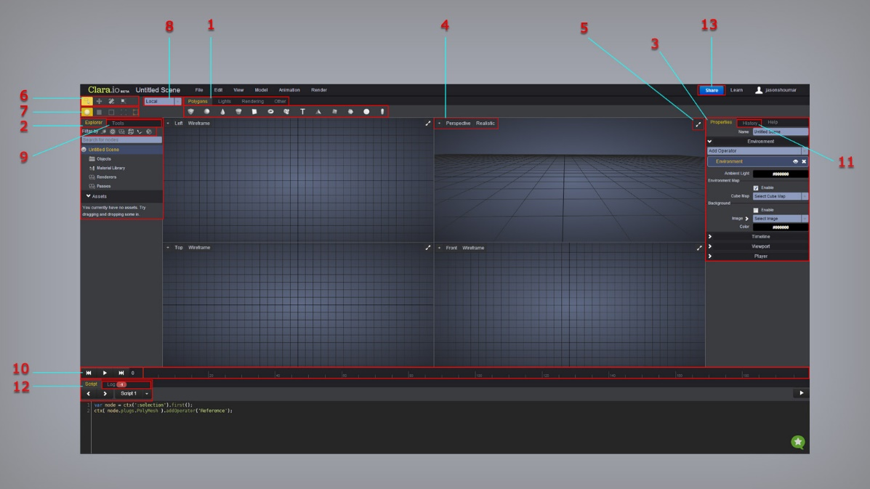

*Figure 3.3: Clara.io interface.*

These tools illustrate the trade-offs: TinkerCAD is simple but too rudimentary for realistic faces, SculptGL is flexible but demands artistic effort, and Clara.io was powerful but generic and complicated. None provide an intuitive avatar customization interface. In contrast, this project’s browser is designed specifically to let users **directly manipulate character features** (e.g. nose shape, eyes color) with smooth interpolation and texture controls, something the above tools do not offer.

## 3.2 Review of existing 3D Character Creators

Beyond general modelers, there are tools dedicated to building 3D characters. These range from professional desktop suites (e.g. Blender’s[12] character plugins) to online or app-based avatar makers. Many game studios have character pipelines (e.g. Mixamo[20]) and tools for amateurs (DAZ3D, VRoid). For this study, we focus on web-based or easily accessible platforms that have similar features to those set out in the objectives for this project. In particular, MetaHuman Creator and Ready Player Me stand out from the rest, offering intuitive workflows and quality results. We discuss each one in detail below.

### MetaHuman Creator

MetaHuman Creator (by Epic Games) is a cloud-based character design app aimed at photorealism. It advertises itself as letting anyone “quickly and intuitively create photorealistic digital humans” in minutes. The process begins by selecting one of the available base characters, all generated from 3D scans of real people. From there, the user can adjust various facial and body parameters using sliders or by combining facial features from multiple characters.

The interface features an editing space where different characters are arranged around a circle (see Figure 3.4), where users can drag the cursor toward the surrounding characters to blend their features.

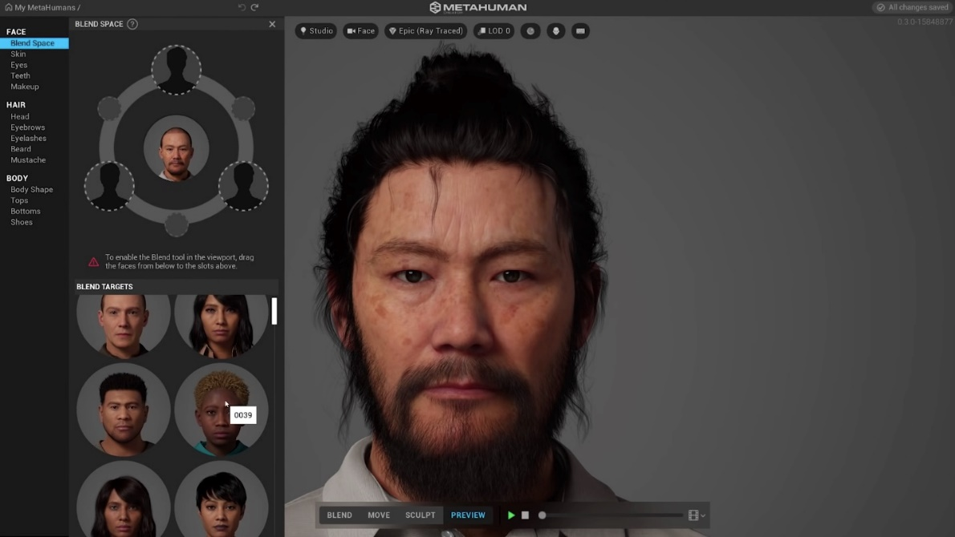

*Figure 3.4: MetaHuman interface, with the interpolation panel.*

This visual interpolation makes it easy to merge features such as eyes, nose, mouth, or jaw. Other body parts can also be customized, such as eye color, skin tone, facial hair, eyebrows, hair (with multiple hairstyles available) and clothing. All these features are edited visually, and changes are immediately reflected in the viewport.

One of its greatest advantages is the quality of the final result: characters created with MetaHuman Creator include full rigging (digital skeleton), high-resolution textures, and up to eight levels of detail, making them optimal for both film and video games. However, its ecosystem is closely tied to Unreal Engine: characters are exported and integrated into projects through Quixel Bridge[3].

**Limitations:** Despite its power, MetaHuman has key constraints. It is *locked into realistic humans*: any feature adjustments are constrained by the scanned data. As the MetaHuman docs note, only “physically plausible adjustments” can be made, meaning you can’t, for example, enlarge the eyes like a cartoon or add alien features without external editing. In practice, artists workaround this by exporting to Blender/Unreal and manually sculpting (Epic even provides a “Mesh to MetaHuman” plugin to convert a custom mesh, but results depend on the input).

Another practical issue is performance: because the interface streams complex 3D assets from Epic’s servers, users have reported it can feel slow or laggy – “painfully slow” to download characters, in one user’s words. Finally, MetaHuman is not freely usable in all engines. This tool is aimed at users who, in many cases, plan to use the models within the Unreal Engine environment.

In summary, MetaHuman offers unmatched realism and detail, but at the cost of requiring the Unreal ecosystem, broad scans-only presets, and a more heavyweight cloud workflow. It has less flexibility for stylized or extreme customization and is not browser-native (you use a browser interface but need Unreal to animate or export the result).

### Ready Player Me (RPM)

Ready Player Me is a web-based avatar creation platform focused on cross-application use (especially social/VR/AR). Users typically start in a web view (on PC or mobile), where they can either upload a selfie or start from a preset to generate an avatar. The interface then offers hundreds of customization options: from hair, clothing, accessories to body proportions and color schemes (see Figure 3.5).

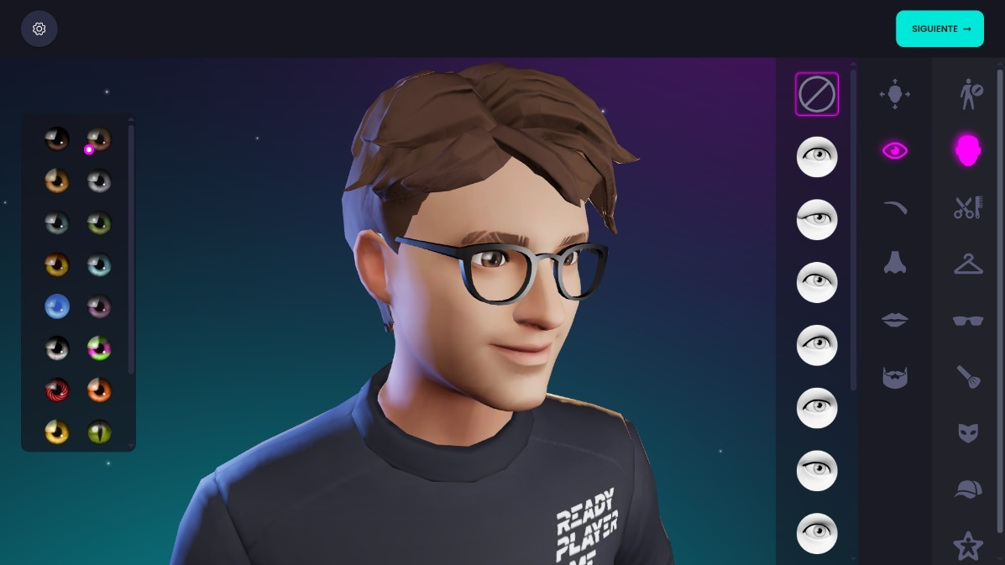

*Figure 3.5: Ready Player Me interface.*

Once finished, RPM gives the option to download the avatar as a fully skinned, rigged 3D model (in GLB or GLTF format) ready to plug into games or apps. It supports both full-body avatars (entire body with legs) and half-body (upper torso and head) versions, optimized for real-time performance. Developers can integrate RPM via SDKs[4] (Unity, Unreal, React, or many others) or simply by loading the GLB file from the provided URL. Many games use RPM for user avatars, thanks to this ease of use and the cross-platform asset pipeline.

**Limitations:** RPM’s design prioritizes convenience and broad compatibility over fine detail. The visual style is stylized/cartoony, not photorealistic (in line with contemporary games like Fortnite[5]). Facial customization is limited to choosing pre-made head types or adjusting overall proportions; there are no sliders for individual nose or mouth shapes. Internally, RPM avatars include predefined blend shapes (for example, the SDK uses “EyeBlinkLeft” and “EyeBlinkRight” to animate blinking), but users cannot modify or customize these morphs beyond what is already provided. Texture changes are likewise pre-set (skin tone options, clothing textures) rather than user-painted. In short, while RPM offers a wide variety of outfits and hairstyles with easy export options, it provides limited control over facial features and lacks dynamic blending or aging effects. It trades good expressiveness for speed and platform reach.

## 3.3 Other Avatar Customization Areas: Social Media and Video Games

Many social apps and games include simple avatar systems as well. These are generally aimed at casual audiences and offer very limited customization compared to MetaHuman or RPM. For example:

* 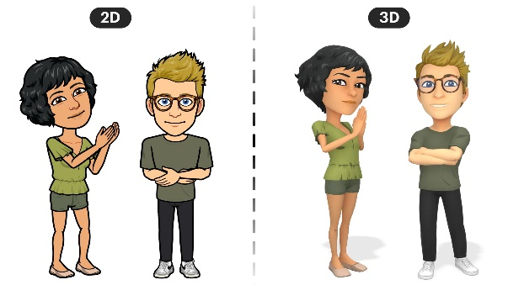**Bitmoji (Snapchat):** it was an expressive 2D cartoon avatar system until the company changed the style of the avatars to 3D ones in July 2023 (a change that is reflected in Figure 3.6). Users pick from a set of face shapes, eye styles, and outfits to create a personal emoji-like avatar.

It's optimized for messaging and augmented reality (AR) filters, not 3D modeling; the character's appearance is more cartoonish than realistic. The control depth is modest (hair, clothes, facial features from preset libraries) and there is no true 3D sculpting.

Figure 3.6: 2D and 3D Bitmojis comparison.

* 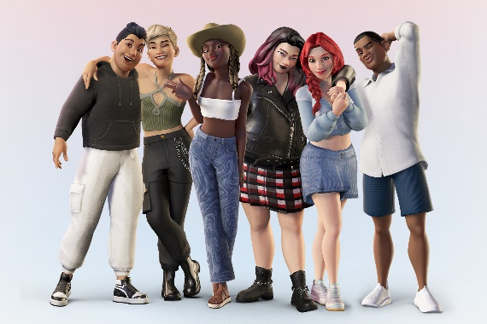**Meta Avatars (Facebook/Meta):** Personal avatars for Meta’s social and VR platforms. Similarly to the last Bitmojis, these use a smooth style and are designed for friendly social interactions (reacting to messages, profiles). Users can adjust facial features, hair, and clothing through a simplified UI, but all options are predefined. The focus is on diversity and expression in social media contexts rather than fine detail (see Figure 3.7).

Figure 3.7: Group of Meta avatars.

_

* 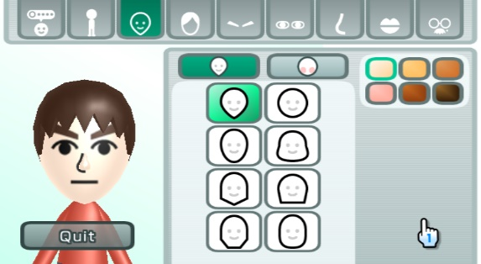**Nintendo Mii:** An avatar system that has become a classic due to its use on the Wii and Switch consoles. Mii Maker allows players to customize very basic facial characteristics: choosing from predefined face shapes (see Figure 3.8), hairstyles, and accessory templates. Users navigate through options like “face”, “eyebrows,” “nose,” “facial hair,” but each choice snaps to a canned graphic. The result is a blocky, low-detail character. _

Figure 3.8: Nintendo Mii face editor.

These examples illustrate that mainstream consumer avatars are typically **simplistic and stylized**, designed for ease of use on phones or consoles. They lack the high polygon counts, realistic shaders, or procedural morphs of tools like MetaHuman. Their target audiences (kids, social users) prefer a “fun” look and rapid creation. In comparison, MetaHuman and RPM target more serious creation (games/VR/film), and offer much deeper visual fidelity. Bitmoji and Mii are very approachable but limited in feature depth.

However, what all these platforms show is the growing importance of 3D avatars in everyday digital interaction. As users we all want to create characters that represent ourselves, not only in style but also in identity and ethnicity (one of my objectives). This highlights the need for tools that support broad customization and inclusivity.

## 3.4 Comparison of RPM, MetaHuman Creator and others

The table below summarizes key differences between these character systems, highlighting where our web-based avatar project fits in:

|  |  |  |  |  |
| --- | --- | --- | --- | --- |
|  | Metahuman | Ready pLayer Me | Social Media Avatars | this project |
| Platform & Integration | Cloud service tied to Epic’s ecosystem (requires an Unreal Engine pipeline). | Web-native and offers SDKs, with output as a standard GLB model | Run entirely on mobile or console apps. | Purely browser-based (no engine required) and can integrate with any WebGL environment. |
| Visual Realism | Photorealistic humans (scanned skin, hair, detailed expressions). | Stylized 3D avatar (between cartoons and photo-like). Essentially the “Fortnite” style of human. | Cartoonish 2D/low-poly, focusing on clear identity rather than detail. | Middle-ground realism: higher fidelity than cartoons, but achievable in real time, with the ability to vary style by user. |
| Customization Controls | Many sliders for facial and body shape, but all are constrained by its scan-based presets. It does not expose raw vertex editing or texture painting. | Allows users to pick from vast libraries of hair, clothes, and some face presets, but no custom morph targets. | Only a handful of toggles (eye shape, hair style, etc. from menus). | Real-time interpolation panels and texture maps (sliding between “wide nose” and “narrow nose” meshes or dialing wrinkle intensity on skin) |
| Export & Use | Fully rigged but primarily intended for Unreal Engine (export via Quixel/UE Bridge). | RPM avatars are optimized for game engines (GLB with skeleton) and can be easily imported into Unity/UE. | Bitmoji avatars are 2D images/GIFs, and Mii are console-specific assets. | Our avatars will be standard WebGL models (e.g. glTF) that can be exported for use in other 3D environments as well. |
| Accessibility & Audience | MetaHuman (free but tied to Epic) is aimed at professional developers/creators. | RPM is developer-friendly (free tiers) and targets cross-platform games/VR. | Bitmoji/Mii target casual social players. | Our project is aimed at end users and creators looking for precise control in a web application. It combines the ease of use of RPM with the detail of MetaHuman, offering intuitive in-browser controls over shape and texture that existing systems don't offer. |

## 3.5 Dynamic Mesh Morphing

At the core of feature customization is mesh morphing. MetaHuman, Ready Player Me, and similar tools rely on blend shapes (morph targets) under the hood. In MetaHuman, each face comes with a set of predefined morph targets for expressions and body shape (though the Creator UI hides these details). Once exported to Unreal, the character uses control rigs and morph targets for animation and subtle deformations. Ready Player Me avatars include blend shapes for facial animations (e.g. eye blinking) and support mappings to ARKit/Oculus face rigs, but these are fixed – the user cannot introduce new ones.

This is important to consider when modifying a character's mesh topology, as done in this project through interpolation with another avatar, because the base mesh to which these animation offsets apply has been altered during the editing process.

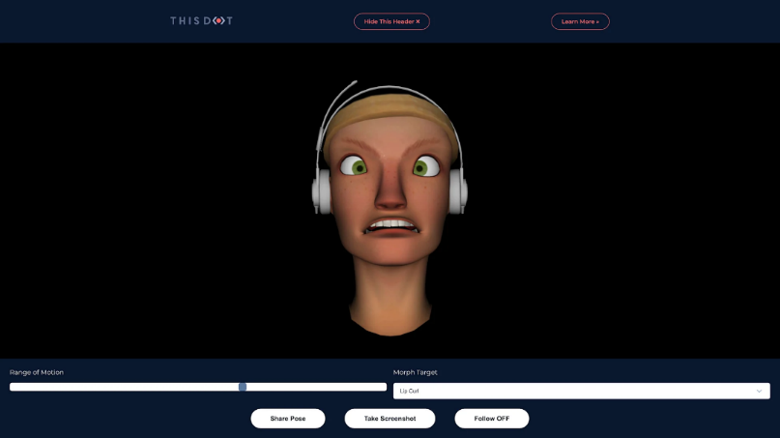Embedding morphing in a web app is challenging because it means recalculating vertex positions on the fly. For example, Google’s “Ginger” demo (2016), represented in Figure 3.9, was a browser-based character with live sliders to tweak facial features. As one write-up notes [19], Ginger shows “a customizable head that uses a slider to tweak various facial features, much like a character customization system one would find in a video game”.

Figure 3.9: Ginger demo with sliders and morph target drop-down

This works, but it required careful optimization (and even then, was presented as a demo rather than a full product). In a real-time web environment, performance and memory are limited, so any large mesh with hundreds of blend shapes can become slow.

**Chapter 4**

# Design and Methodology

The following section describes the conceptual and technical design used to create OasisMe, a web application for customizing Ready Player Me (RPM) avatars. The platform includes a 3D scene where the avatars' customizable properties can be modified, reflecting the changes in real time. First, the key principles for 3D environments will be described, and then how these principles influenced the initial design, technologies, and tools chosen for the application.

In order to organize the timing of the project, a task scheduler was created. Shown in Annex D, this tool was used to follow some order in the implementation and adhere to defined timeframes.

## 4.1 Principles of User Interface Design for 3D Applications

A well-designed interface not only needs to be visually appealing but also to allow users to interact with 3D elements in an intuitive and efficient way.

One of the main principles is **simplicity**. Even though the code of the interface may be very complex, the platform should be presented in an accessible way to the users. To accomplish this, elements should offer visual feedback and have logical interaction. As the interpolation tool could seem complex, we will need to keep this principle in mind when choosing the interpolation controls, because they need to be functional and easy to understand. These controls must also be clearly labeled and put together according to the part of the face they affect.

**Real-time feedback** is another essential aspect. Any change users make (like clicking in a recoloring button to change the eye color) should be instantly visible to help them understand the effect of each interaction. To implement this, we will get helped from the Three.js library, which makes it possible to implement real-time rendering directly in the browser.

Interaction techniques such as zooming, rotating, and translating with respect to the model are essential to being aware of what we are editing and how we are influencing the scene. Since this project is primarily intended for desktop use, these functions should be implemented through intuitive mouse and keyboard controls. For example, dragging with the left mouse button to rotate, using the scroll wheel to zoom, and right-clicking or holding Shift key while dragging to pan.

Following the study made by Lee et al. (2009) on usability principles and best practices for the user interface design of complex 3D parametric tools [6], we can understand the importance of minimizing cognitive load, organizing control groups logically, and (as mentioned above) ensuring immediate feedback from the system. While their work focuses on architectural applications, many of the principles identified are directly applicable to an avatar customization interface, where the balance between complexity and usability is critical to achieving user goals.

## 4.2 Initial layout

Following these principles, the initial design of OasisMe pretends to be both aesthetic and functional. The name itself reflects the project’s main purpose: to offer every user a space where they can see themselves represented in a digital world, a technological oasis where diversity is valued. To integrate this concept into the interface, we have decided to change the classic layout of a 3D modeling web-based application, like the ones seen in section 3.1. This one inspires a sense of respite with a paradisiacal background and blue tones in the buttons and titles.

From a functional design perspective, the interface focuses on simplicity. The screen layout will be divided into two main areas: a central 3D viewport where the avatar will be rendered in real time, and a side panel with controls grouped by customization utility. All components will follow a minimal and intuitive aesthetic to keep cognitive load low.

Three core customization features have been chosen and emphasized in the layout due to their expressive power and social relevance:

**Interpolation**

The interpolation feature will be the most technically complex and expressive customization option in OasisMe. It will allow users to blend facial traits between their current avatar and a chosen one from the hole set of predefined by moving a slider. This slider will control the weight of a morph target, which will smoothly adjust the mesh geometry by interpolating vertex positions. The weights will range from 0 to 1, where 0 represents the original shape and 1 fully applies the geometry of the example avatar for the selected facial region.

For this prototype, five facial regions have been selected for morphing: nose, eyes, ears, jaw, and chin. These areas have been chosen because they represent the most distinctive traits across Ready Player Me avatars. By offering control over these zones, users will be able to craft subtle or dramatic changes in appearance. The actual selection of these mesh regions is illustrated in Appendix A.2.

**Recoloring**

The recoloring feature will be easy to apply but also a powerful way to change the identity of an avatar. Users will be able to adjust skin tone, hair color, eye color and cloths color with a predefined range of colors fixed on different buttons.

This functionality is particularly important in the context of diverse representation. Skin color is a key component of identity. By offering this control over skin tone, the application will avoid the limitations of preset categories and will better reflect the wide variety of human appearance.

**Aging Effects**

Finally, the aging panel will let users simulate the passage of time by adding wrinkles and grey hair to their avatar. This feature addresses a key gap in most avatar systems: the ability to represent older users. In many digital environments, age diversity is underrepresented, and aging effects are rarely included as part of customization pipelines. In OasisMe, aging will be handled through texture blending in the shader.

The project, as said before, empowers users of all ages to see themselves represented, not just idealized youthful versions. It also opens the door to applications in storytelling, education, and medical visualization where age variation may be relevant.

Going back to the principles seen in section 4.1, all customization options have been designed with real-time feedback in mind. Any change the user makes will be immediately reflected in the avatar preview. This reduces the barrier to experimentation and makes the interface feel responsive and dynamic.

**User Flow**

The user flow follows a clear and linear structure through these functionalities to avoid confusion. It is represented as a concept map in Figure A.1 at the Appendix section. The following points are a brief overview of what was originally intended to be done:

* 1. Load base avatar: the user can start with a default Ready Player Me character, preloaded into the viewport, or with a personalized one uploaded from their own files or with a RPM URL.
  2. Modify geometry: using the interpolation panel, the user can combine features from different example avatars stored in the system.
  3. Adjust visual appearance: the user applies texture-based changes, such as recoloring, or adds aging overlays through dedicated panels.
  4. Preview and finalize: the avatar can be rotated, zoomed, and inspected from all angles. Users can adjust details as needed.
  5. Export avatar: finally, users can download their creation in GLB format, ready for use in external environments like Unity or Unreal.

This structured yet flexible flow ensures that users of all skill levels, regardless of their technical knowledge, can intuitively navigate the app and create personal avatars.

**Technical Implementation Overview**

While the interface has been designed with usability in mind, its underlying architecture will need to have appropriate web technologies and libraries to handle the interactive complexity of the application.

The project will be developed entirely using HTML, JavaScript, and CSS, languages ​​that define the structure of most web pages.

For 3D rendering, the Three.js library will be used, as it allows for real-time manipulation of graphics and models within the browser. Additionally, two GUI libraries will be used: Litegui[6] (for panel management and layout) and LexGUI[7], which simplifies the creation of pop-up alerts, user input panels, and 2D interpolation maps.

In terms of avatar blending, the interpolation between characters will be implemented using a morph target system, where vertex positions from different models are blended using weights. The user selects which avatar regions to interpolate from those seen in Appendix A.2, and the system computes the intermediate mesh by using the method explained in Section 2.2.

The interpolation system's idea allows for the simultaneous combination of a base avatar and three additional avatars. The structure chosen for combining these characters is a Voronoi Cell[8] panel (from LexGUI library), where each target is placed in a corner of the cell and the user's selection moves within it to control the blending weights.

These implementation decisions ensure good performance but also reinforce the core mission of the project: offering an accessible platform where users can represent themselves. Being fully open-source, this application is also extendable and can be adapted for other projects.

## 4.3 Evaluation Methodology

After creating the web platform, we will conduct a usability test to evaluate its ease of use and how users accomplish the task of customizing an avatar.

The evaluation will be conducted through a questionnaire that participants will complete after interacting with the application. The questionnaire is designed to assess various aspects of the user experience, such as interface clarity, error handling, global vision, and subjective perception of the experience.

The test will be conducted online through a Microsoft form and will be anonymous to ensure participants feel comfortable providing an honest assessment. It includes demographic questions, as well as Likert scale questions to assess the interaction flow. All screenshots of this test can be found in Appendix B.

It will be sent to a diverse group of users, primarily between 18 and 45 years old, with technical and non-technical backgrounds, to better assess accessibility. Participants will be explained that the purpose of this website is to customize avatars, as they would in a video game or on a social network, to create their own. They will be asked to complete the task of customizing an avatar and exporting it. They will do this without assistance, although they can ask questions if they feel completely stuck.

The evaluation does not only focus on the visual design of the interface, but also on the correct implementation of its underlying technology, including the rendering performance and how the different GUI panels support interaction.

**Chapter 5**

# Implementation Process

This section outlines the hole process for the development of the web-based 3D avatar customization tool. Each subsection corresponds to a phase of the project, from initial setup to advanced features. Also, the problems encountered and how they were resolved.

Of course, the process has been much longer than stated below. There have been many minor tweaks to the code throughout the process, either due to minor bugs or to the website's overall design and aesthetics. However, the most significant aspects of the development are described in detail below.

## 4.1 Environment Setup and Data Preparation

As seen in section 1.2, and throughout the project in general, this tool is designed for use on the web. That's why we started by installing the Live Server extension in Visual Studio to serve pages locally with auto-reloading. Live Server runs a lightweight HTTP server on the local host, allowing you to preview HTML/JavaScript without a separate backend. It can be started via the status bar “Go Live” button which yields a local URL (this is, *http://127.0.0.1:5500/index.html*, which started as test.html as seen in Figure 4.1), the one that has been used during the entire project in Google Chrome.

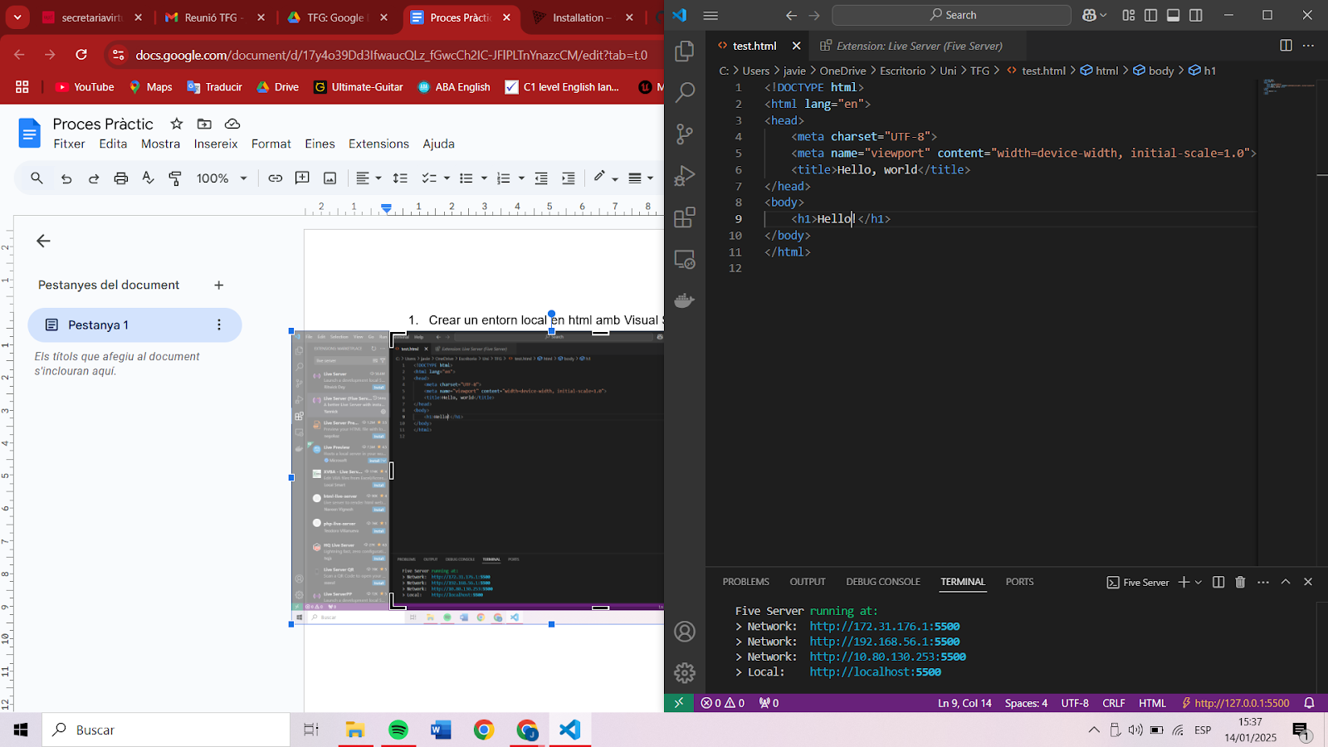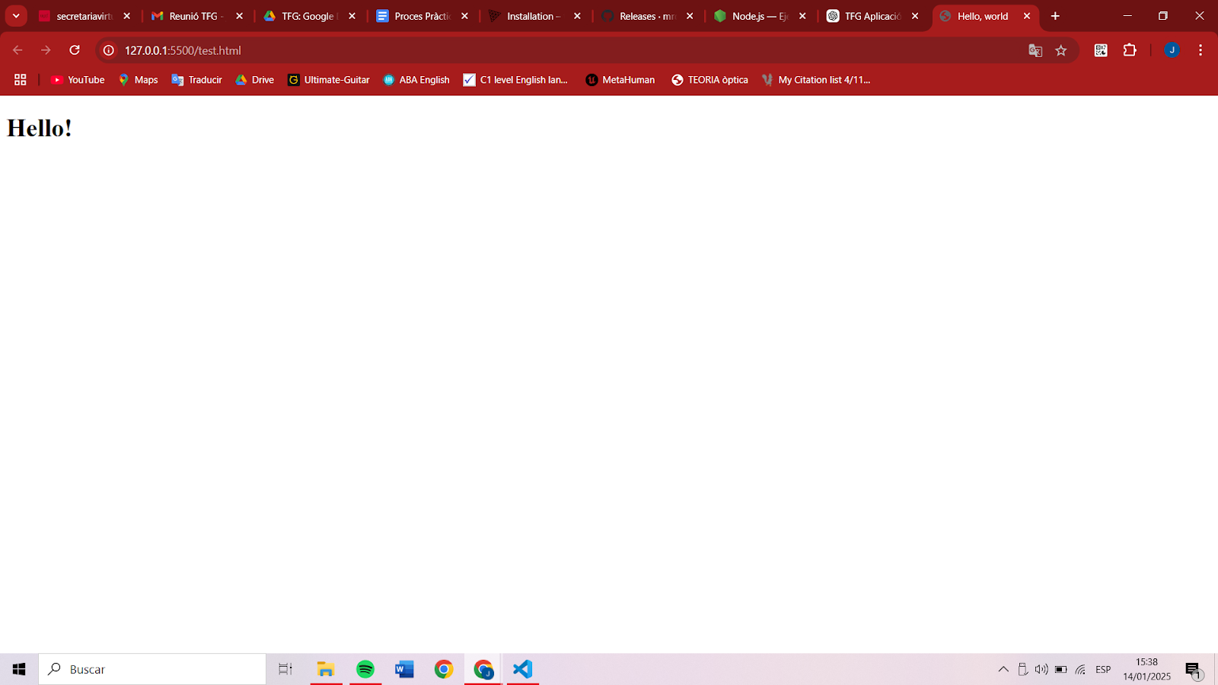

Figure 4.1: Initial test.html code (left) and its Live Server preview (right).

The Three.js library was installed and imported. A basic HTML and CSS structure was created, and a secure HTTPS configuration for local development was implemented using a self-signed SSL certificate to avoid browser restrictions during testing.

**Integration with Ready Player Me**

The Ready Player Me (RPM) API was integrated following official documentation[23]. An application was registered in RPM Studio, from which the subdomain and access token were obtained. Avatar templates were fetched via authenticated API requests.

When a user selects a template, the app must create an RPM avatar and possibly save it. The Ready Player Me API uses a two-step process: first, do a POST to create a new draft avatar, which returns an avatar ID. Then do a PUT to save it permanently (otherwise the draft expires). Our code’s *assignTemplate()* function does exactly this: it fetches POST *https://api.readyplayer.me/v2/avatars/templates/${templateId}* with the subdomain in the body, receives a temporary id, then immediately PUTs the same endpoint to save it. We store these IDs so that once an avatar is created or saved, we can later fetch it by ID. Essentially, the PUT step finalizes the avatar on the server, and is required to “lock in” the selected template.

**Vertex Region Selection**

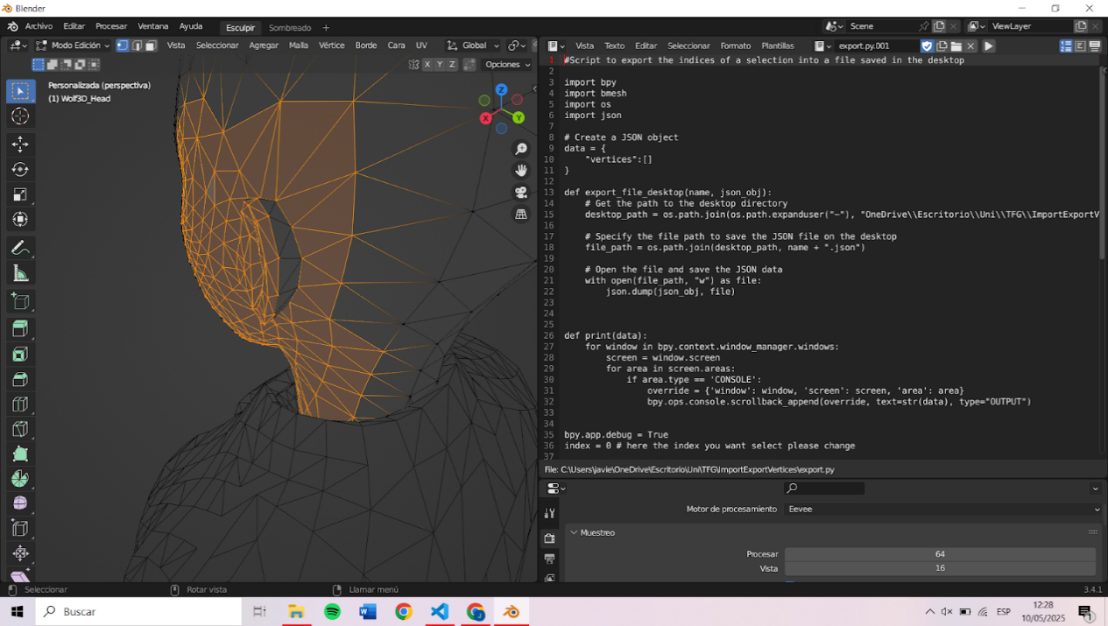To store the indexes of the vertices of each facial region that we want to perform the interpolation (e.g., nose, eyes, ears), a verticesGlobal.json file needed to be created. The data was generated using Blender[9] and Python[10] scripts (import.py and export.py) provided in Oriol’s TFG. In Blender, each facial part was manually selected, and the export.py script was run to extract the vertex indices. These were saved to a vertices.json file and later consolidated into a global verticesGlobal.json used by the application to identify the correct vertices during morph generation. All these selections of vertex sets can be seen in section C of the Appendix.

While working on the interpolation tool, we noticed a problem with the meshes in Ready Player Me. When interpolating the ears with an avatar with large ears, the source avatar's ears were slightly separated from the head at the back. At first, we thought we might not have selected enough vertices, so we re-extracted them with the Python scripts in Blender. When that did not solve the problem, we realized some mesh parts are not properly connected. The issue comes from the model itself, as can be seen in Figure 4.2.

Figure 4.2: Selection of the vertices on the left part of the face

## 4.2 Avatar Rendering and Interface Architecture

Avatars were loaded using Three.js’s GLTFLoader and added to the scene. The scene setup included basic lighting, a camera, and a WebGL renderer. A canvas and rendering loop were initialized to maintain interactive visualization.

**User Interface Design and Sidebar Construction**

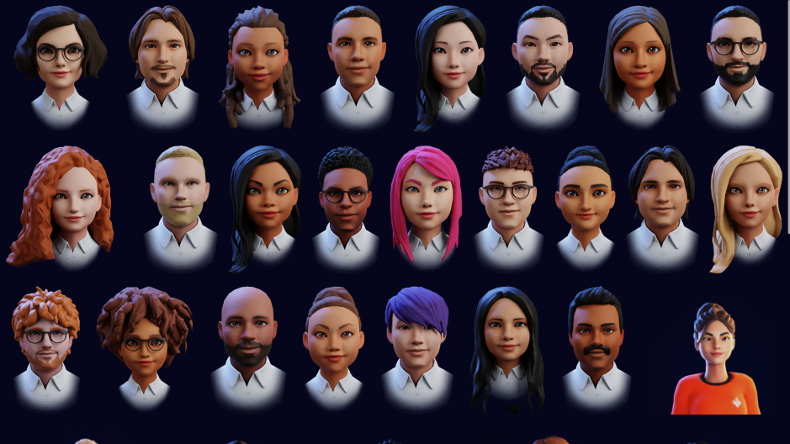The first thing done after creating the canvas with the avatar in the center was to add a preliminary page where the user chooses from several thumbnails of all the available avatars (see Figure 4.3). These are displayed in a gallery and the one selected by the user will be the source avatar, which will serve as the basis for any editing tools we want to use. In “Support for Custom Avatars” section will be seen that a button was later added to import RPM models through an URL or from a local archive.

Figure 4.3: Preliminary page with all available avatars

Right after this, a collapsible sidebar was created using native HTML elements. Three main panels: Interpolation, Recoloring, and Aging Effects (before Wrinkle Map) were designed as expandable sections. We will start by diving into the first section. The other two will be explained in detail in section 4.4 as they were implemented later.

Initially, the first panel featured five sliders, one for each interpolable part (nose, eyes, ears, jaw and chin). Thumbnails of all available avatars were displayed in a gallery again, but this time allowing users to select the reference avatars (targets). The user had to select one of these and move the sliders to interpolate with the original model. The interpolation process is explained in detail later, in section 4.3.

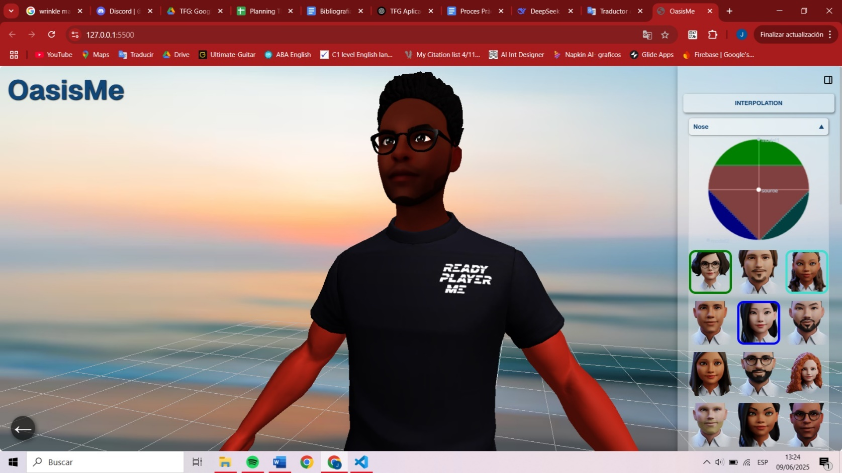This section was changed because we decided to incorporate more advanced interpolation, allowing interpolation with more than one avatar at a time. To achieve this, we added five subsections (one for each interpolable part). In each one of them, the user can choose up to three reference models and interpolate with them.

Then the sliders were changed to advanced user interface (UI) panels. So, that is why this project integrated the LexGUI library. To allow users to interact with a 2D control map (Map2D), where characters can be added to the edges and the space gets divided like a simplified Voronoi diagram. By moving the control point across the map, the weight of each reference model is computed based on the pointer’s proximity to each vertex. As the pointer gets closer to the edge with a certain color (identifying a certain model), the weight for the interpolation with this model increases. The system interpolates between multiple avatars using weighted morph targets, explained in the next section, enabling smooth transitions and hybrid faces.

When a reference avatar is selected, its thumbnail is highlighted with a colored border (green, blue, or turquoise), which relates the avatar with one of the edges of the interpolation panel of the same color. This selection is maintained when interpolating to clearly see which part corresponds to each avatar selected (see Figure 4.4).

Figure 4.4: Sidebar with Interpolation panel open

This library was also useful to implement warnings and messages to the user when something went wrong, or something was missing. An example of this is the message that appears when the user has not selected enough reference avatars to interpolate, or when the user has selected too much.

## 4.3 Morph Targets and Interpolation

This project implements a morph target system to interpolate facial features between avatars. As seen in section 2.2, morph targets are generated by computing the difference between vertex positions in the source and target avatars. This difference called delta is then multiplied by a weight and added to the original source vertex position as seen in the following formula:

$${VtxPos}_{final}={VtxPos}_{source}+α∙\left|{VtxPosCentered}_{target}-{VtxPosCentered}_{source}\right|$$

Morph targets are generated each time a new reference avatar is selected. At that moment, the system calculates the deltas between this new target and the base avatar. Previously selected targets maintain their own morph targets. This approach optimizes performance by avoiding unnecessary recalculations and ensures that each morph interpolation remains consistent to its corresponding reference avatar.

Initially, the computation was wrongly done by subtracting directly the position of source and target vertices. Later, we realized that there were differences in the height of the avatars, which distorted the result. If we wanted to interpolate a short avatar with a taller one, the part interpolated was elevated to the height of the second. To compensate for this difference, a normalization function was applied. We calculated the geometric center of the vertices and compensated for the delta by extracting this center from the array, ensuring that the morphs were relative to the center rather than absolute.

Another error occurred, which was probably the most significant one because it took a while to notice. When accessing the position of the vertices, the array was accessed as if there were only position elements. So, looping thorough taking all the elements three by three. However, we later realized that we were working with an interleaved buffer[11] containing thirteen elements of stride (for position, normal, uv, color). Once we identified the issue, we corrected the approach by taking the first three elements to apply the formula of normalized difference in position, but the remaining elements were also processed by taking their direct difference and adding them to the delta array.

In the code, *getObjectByName()* identifies which subset of vertices (all the subsets are seen in Figure 4.5) corresponds to a facial feature, and *morphArray()* computes the difference between two avatar’s attribute arrays for that part and stores it in *morphTargetInfluences*. For performance, we store only the delta rather than full attribute data each time. By computing these arrays ahead of time and only once, the real-time interpolation (adding scaled deltas to the original model) is much faster.

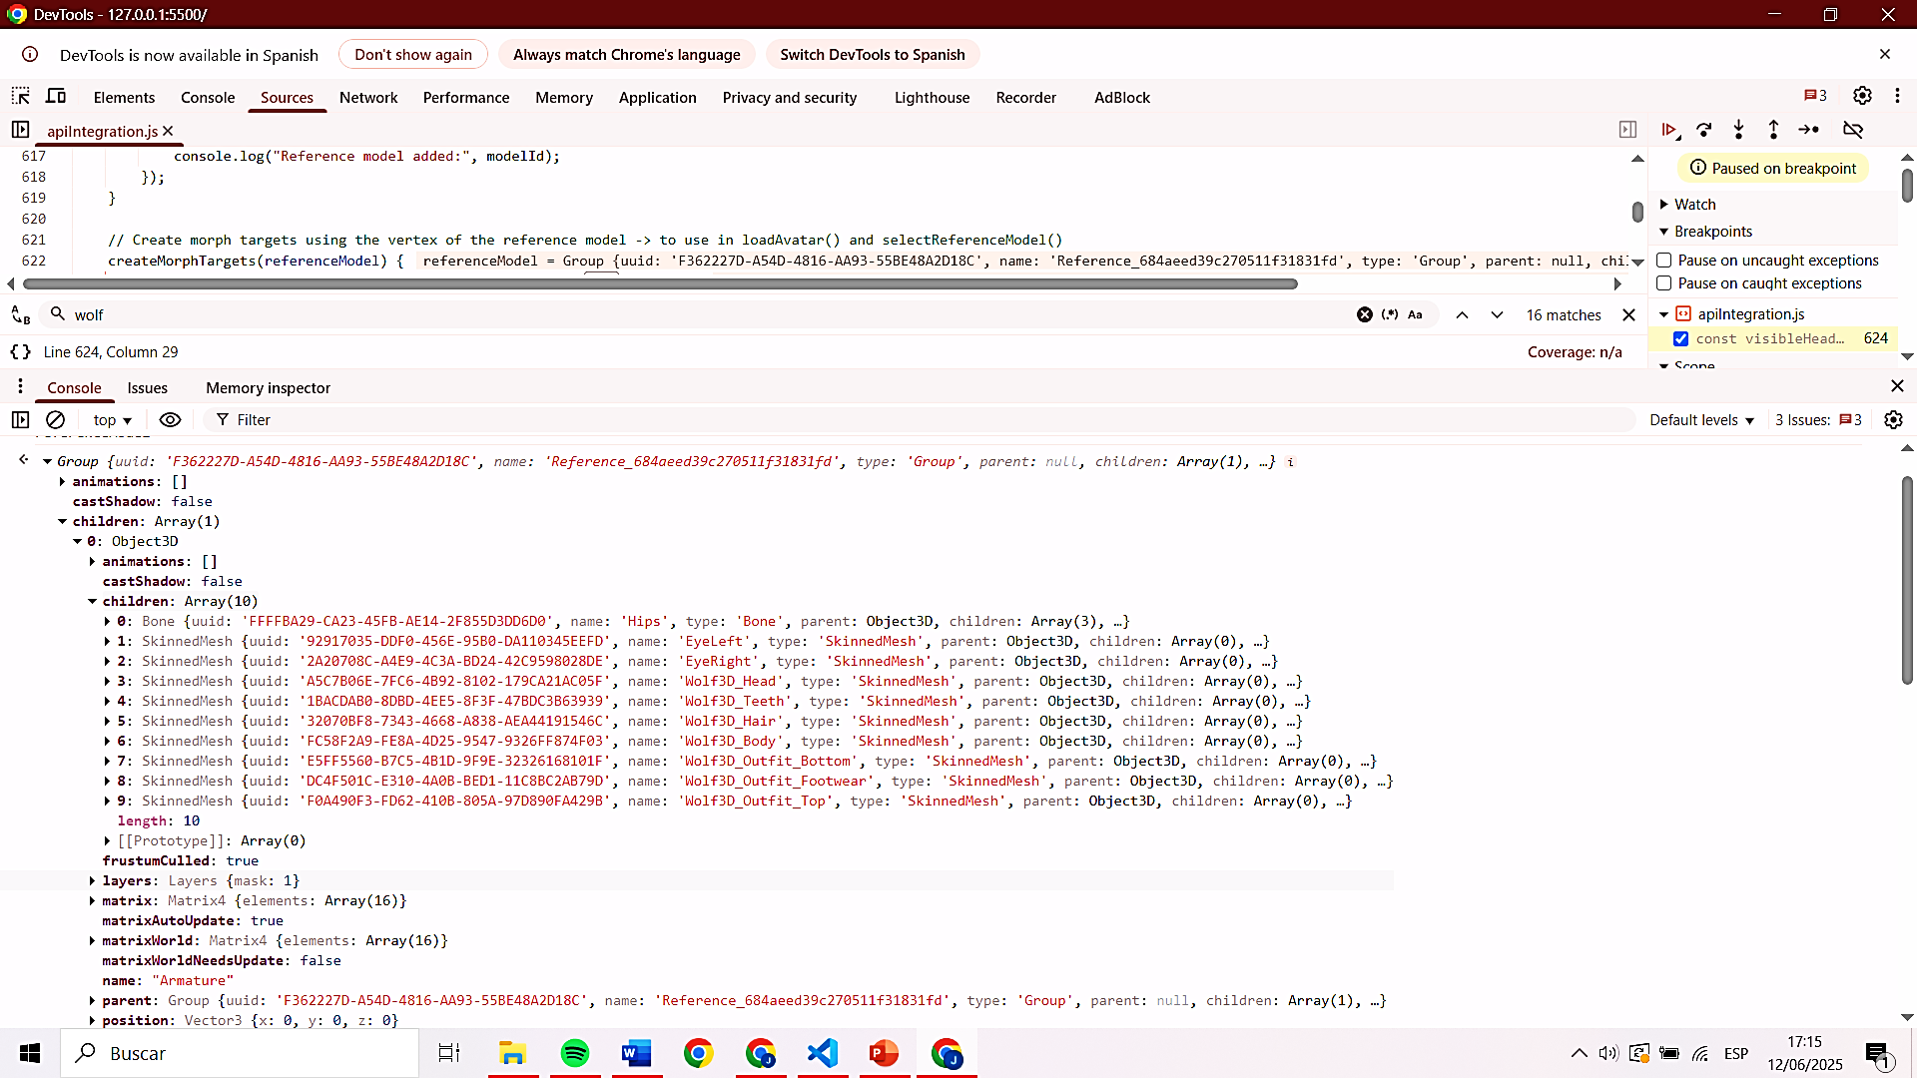

Figure 4.5: All subset of meshes in the avatars of Ready Player Me

## 4.4 Customization Tools and Advanced Features

**Recoloring Features with Texture Masking**

A recoloring system was implemented for skin, eyes, hair, and clothing. Initially, the *.material.color.set()* method of the mesh was used to tint each selected part, but this method presented a problem. When the underlying texture was dark, the color filter was barely visible. This occurred because the method doesn't replace the colors of the original texture, but rather multiplies them, causing darker areas to display a minimal tint while brighter regions display the desired hue.

To fix this, white-based textures were used to allow color overlays without distortion. These textures were extracted directly from RPM characters with an online texture extractor and edited with an image editor. Figure 4.6 shows some examples of these:

Figure 4.6: White-based textures of hair, shirt, shoe and pants; from left to right.

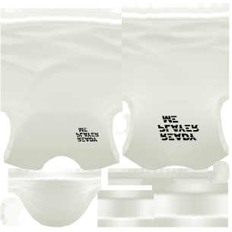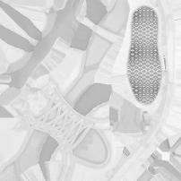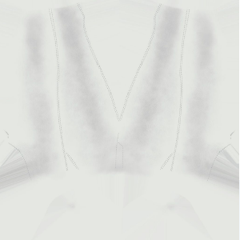

For eye recoloring, a mask-based shader was developed: a grayscale eye mask texture allowed coloring only the iris while preserving the white part of the eye. This shader blended the base texture and the color tint based on the mask’s intensity.

Finally, we have added a "Recolor Original Texture" checkbox for each color section that, when enabled, applies color as a simple filter over the existing texture instead of replacing it.

**Wrinkle Maps and Aging Simulation**

Using a texture overlay, wrinkle effects were added to the avatar's face. A slider in the Wrinkle Maps panel controls the opacity of this wrinkle layer, allowing for a progressive display of these aging effects. This was achieved by blending the original face texture with a wrinkle texture in a fragment shader, using the slider value as a weighting factor. The wrinkle texture was created manually by combining different images (black and white and inverted) of facial wrinkles. The image quality was later enhanced with AI as we can see in Figure 4.7.

Figure 4.7: Wrinkle texture manually done(right) and improved with AI (left)

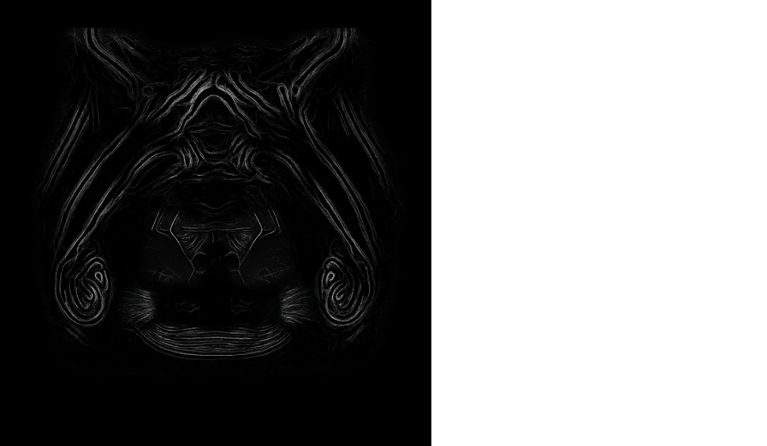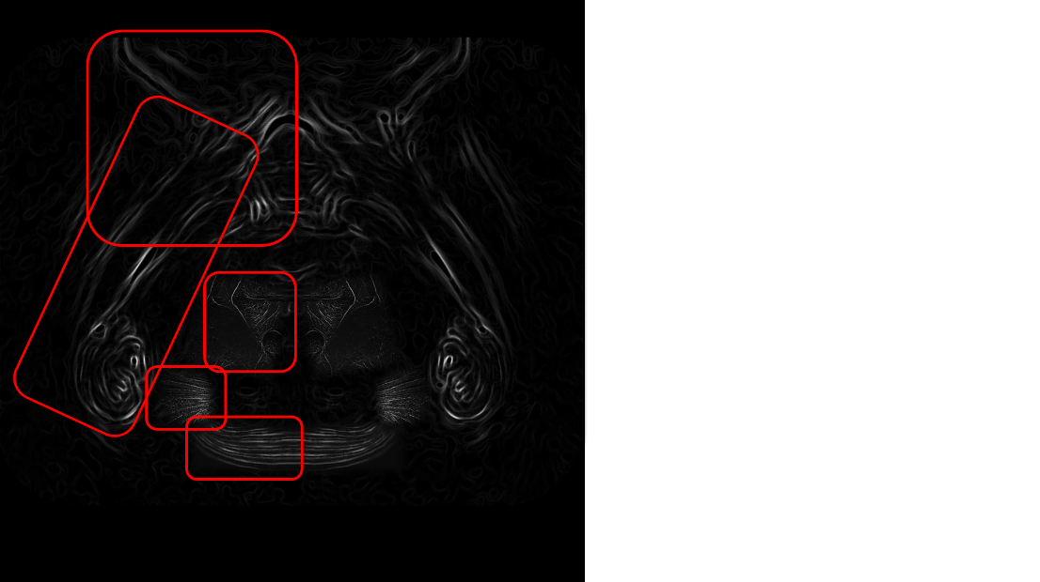

Later, another slider was added to this section to control the intensity of a gray filter that is applied over the hair texture (using the function *applyColorToPart()* which was created for the recoloring).

**Support for Custom Avatars**

In addition to RPM templates, the app supports user-provided avatars. We created a LexGUI dialog with two inputs: one for a URL and one for a file upload. The URL input expects a readyplayer.me model link (e.g. *models.readyplayer.me/{id}.glb*) provided by the RPM studio when you have just created an avatar, from which we extract the avatar ID. When a .glb file is selected, we use the browser’s File API to load it. Importantly, Three.js loaders require a URL, not a File object, so we create a temporary object URL.

Error handling was added to detect invalid URLs or unsupported files. Since we need to create this temporary URL when uploading a file, the avatar ID must be specified in the file name. When downloading a .glb file directly from the RPM server, its name is already set to the avatar ID. However, if the name is changed or the user wants to use an external .glb file, the application will not be able to perform the PUT step explained in section 4.1. This is why it is necessary to send an error message if the file does not have the correct name.

The user’s custom avatar is treated like a template, added to the beginning of the template list (so that we can see the custom avatar first without having to scroll down), and morphable just like the presets.

**Final UI Improvements**

To improve user interaction with the interface, various elements were added. The first addition was a "Back" button to allow users to return to the initial selection screen, resetting the interface and scene. A loading indicator was then added to indicate the avatar loading progress.

Later, a button was added to hide/show the sidebar so the user could better analyze the customized avatar. The layout was adjusted to ensure the canvas remained unobstructed and that the sidebar did not interfere with mouse controls.

Finally, the CSS styles were refined to ensure consistent styling, correct icon placement, and responsive behavior across all devices. More details on the final design will be explained below.

**Chapter 6**

# Results

This section focuses on the results of this project, describing the interface in detail with all its elements, and the possibilities they bring to the user. Then, an analysis is made of how this application allows the user to customize their own avatars: what it allows them to modify and its limitations. This analysis is also supported by the responses from a usability test of the application conducted on a group of people.

All the code and resources needed to make this project are available on GitHub. Use the link below to access the repository and set up the web application locally:

<https://github.com/javiportabella/TFG_AvatarCustomization.git>

Also, GitHub Pages permitted us to upload the application and provide public access to the website, allowing users to test the customization tool directly from their browsers without any installation. Follow the following link to test the platform:

<https://javiportabella.github.io/TFG_AvatarCustomization/>

## 6.1 Final Interface Description and User Flow

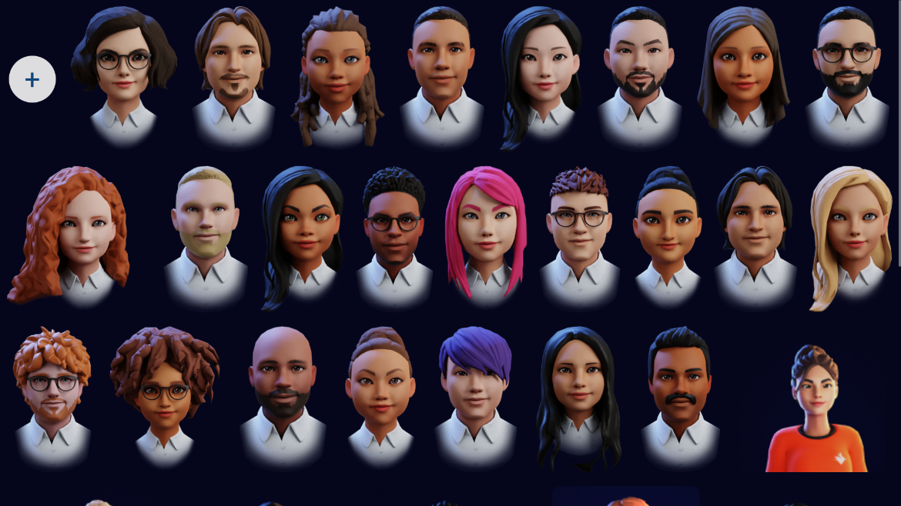The final interface design was built around a responsive, component-based layout. Upon launch, the user is presented with a full-screen grid of avatar thumbnails, as seen in Figure 6.1. These models can be selected to be used as source models as well as the ones optionally added by the user.

Figure 6.1: Preliminary page with available avatars and plus button to add new ones

When clicking into an avatar, a spinner appears while avatars and resources load. This prevents the app from seeming unresponsive. When the scene is fully loaded, a full-screen canvas appears with the selected 3D avatar at the center, with the disposition presented in Figure 6.1. From this point, it is possible to rotate, zoom in, zoom out, or move relative to the avatar. Also, a grid floor is visible at the avatar’s feet, providing a grounding reference that enhances spatial orientation. This grid helps users understand the rotation and movement of the avatar relative to the scene.

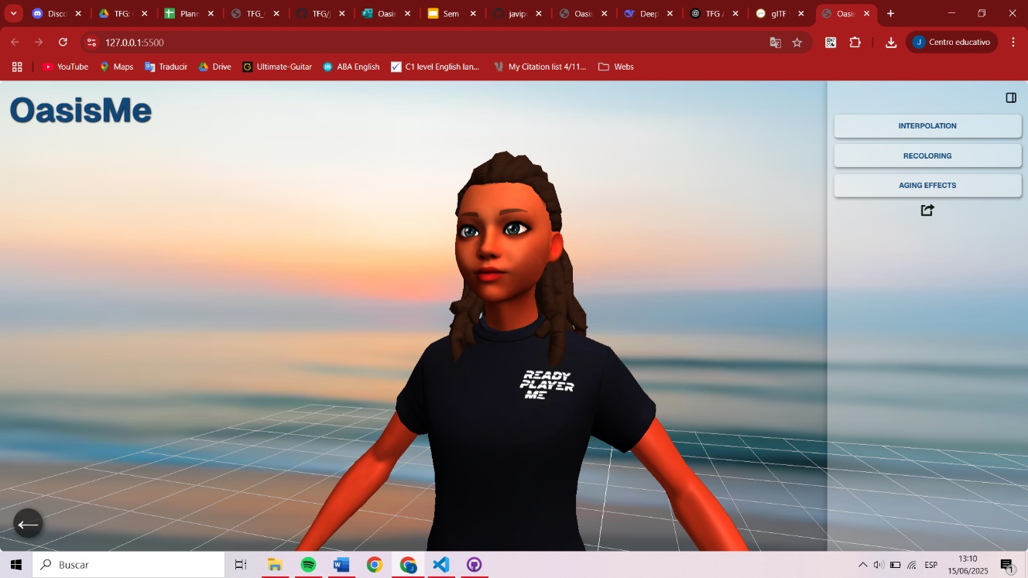

Figure 6.2: Layout of the application’s main page

A collapsible sidebar on the right groups the main functionalities into three expandable sections: Interpolation, Recoloring, and Aging Effects. Each section only reveals its contents when needed (see Figure 6.3), minimizing clutter and cognitive overload. This reflects the principle of progressive disclosure, allowing users to focus only on the active task.

0

Figure 6.3: Sidebar layouts (from right to left): general view, Interpolation section (expanded), Eyes subsection (expanded), Recoloring section (with subsections expanded), and Aging Effects section (expanded).

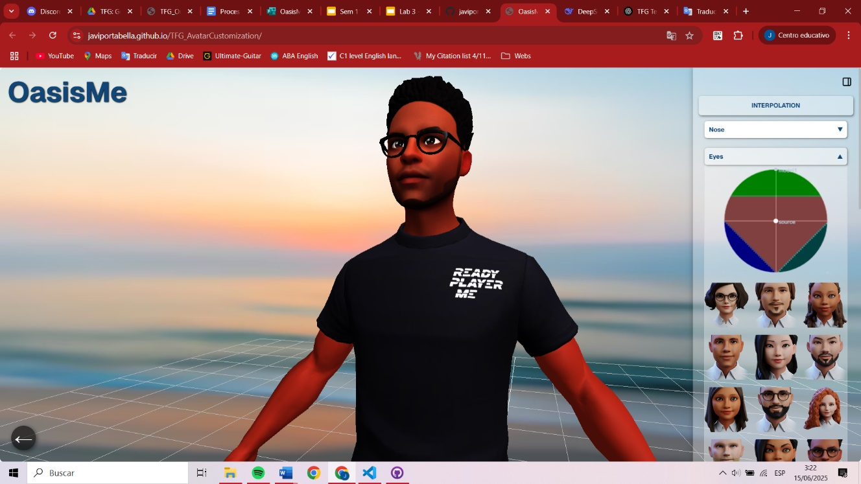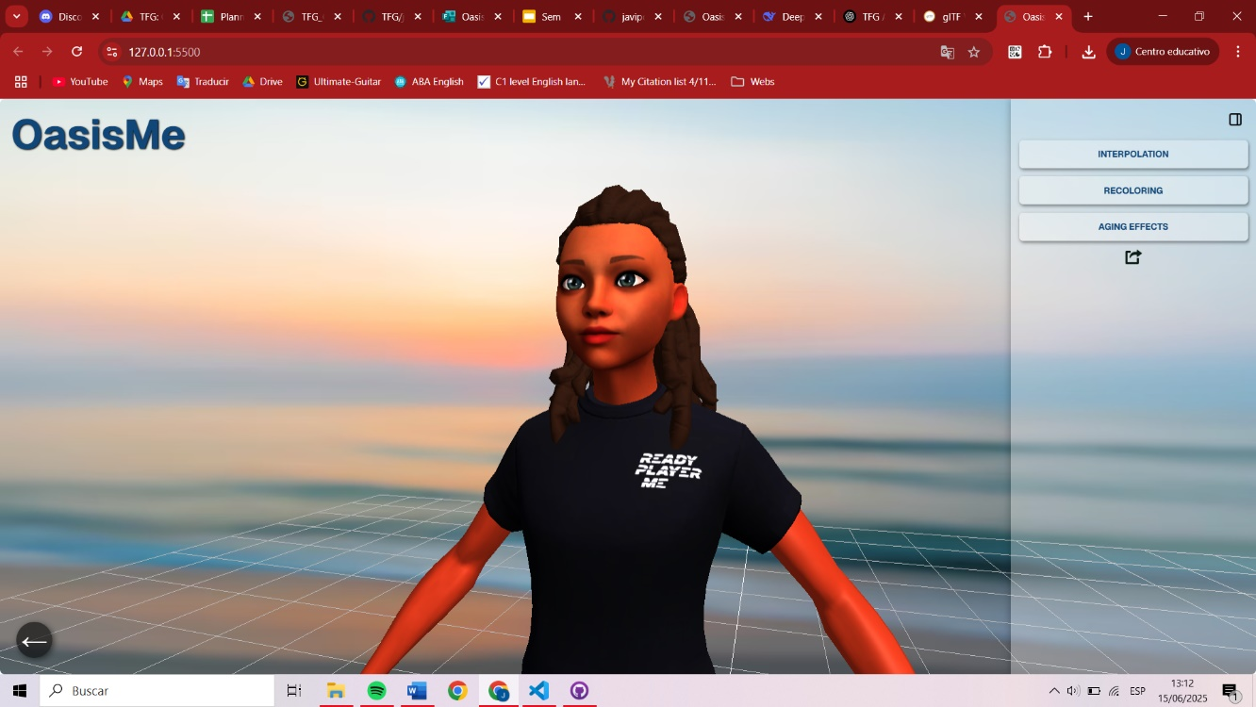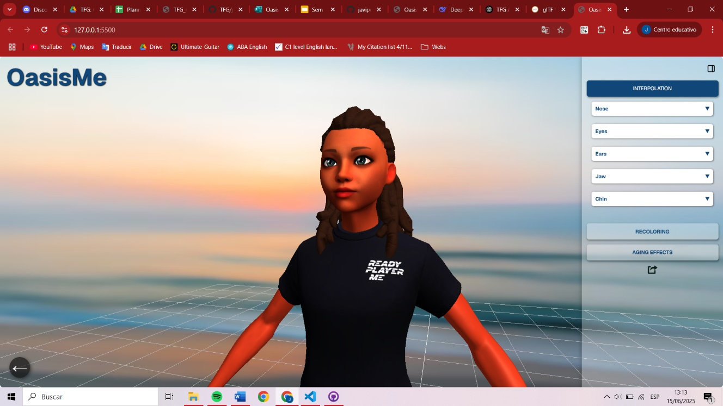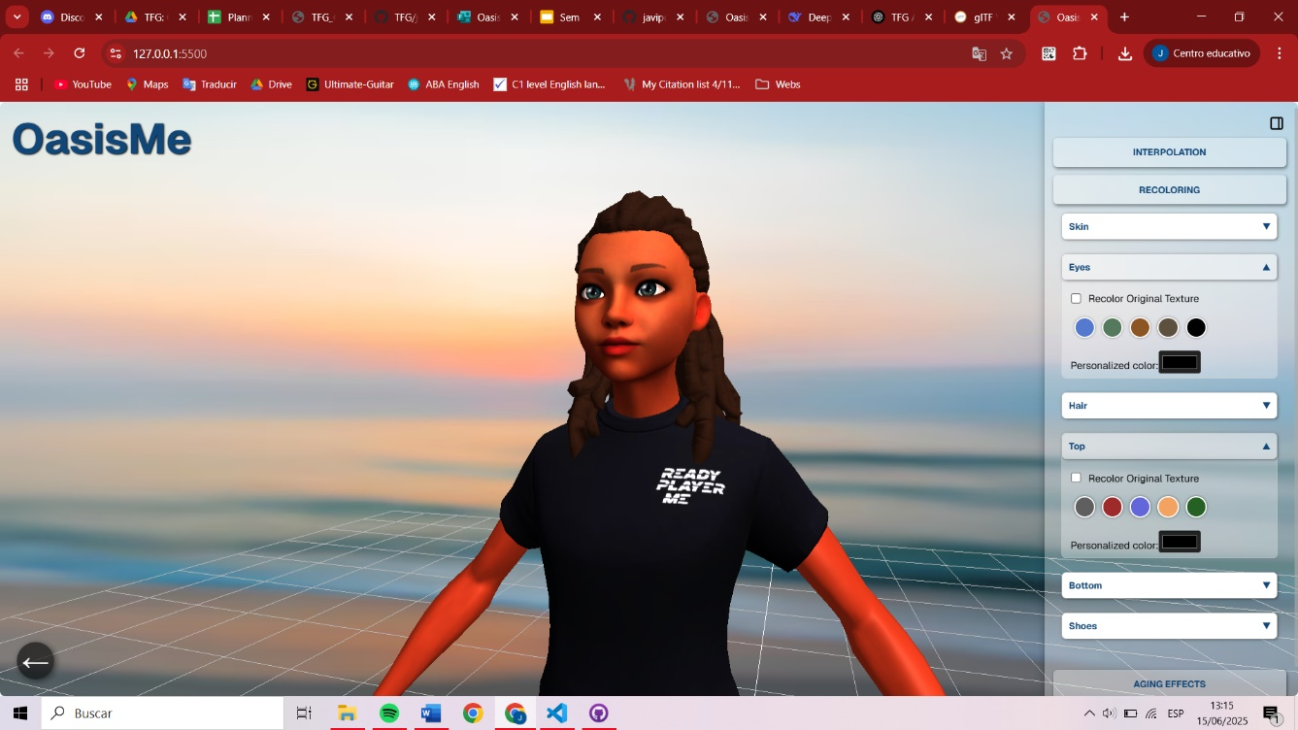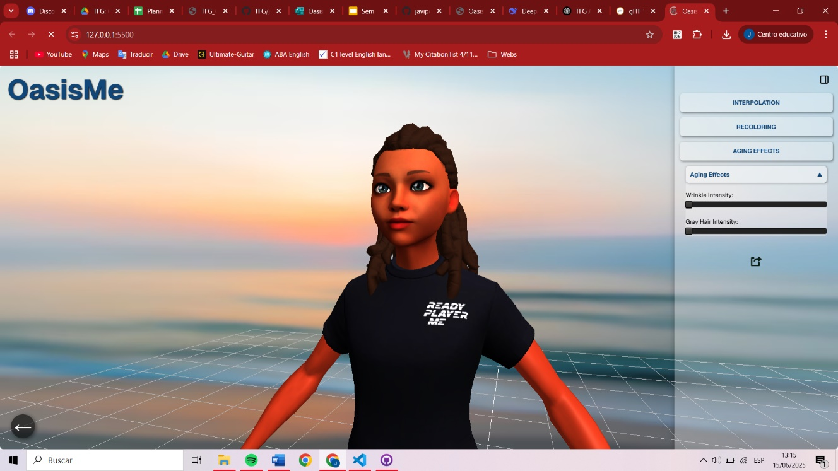

Within the Interpolation section, users can select specific parts of the face (e.g., nose, eyes, jaw) and, once three avatars are selected from a grid of avatar thumbnails, the Voronoi panel activates, and it allows the blending of multiple models.

In the Recoloring section, users can select different body parts such as skin, eyes, hair, or clothing and apply color changes using swatches or a custom color picker. When selecting the checkbox, it is possible to preserve the original texture and apply an overlayed color filter, giving users more flexible styling options.

The Aging Effects section includes two sliders. The first, overlays facial wrinkles progressively using transparency blending. The second applies a progressive recoloring of the hair from white to gray (a range typical of hair color in old age).

Eye recoloring and wrinkle effects are rendered in real time using GLSL shaders via THREE.ShaderMaterial, allowing masked blending and color tinting controlled by the UI elements.

Additionally, a floating sidebar toggle button in the top-right corner lets users hide or reveal the interface at any moment, preserving screen real estate during avatar inspection. A back button allows users to reset the app state and return to avatar selection. This is a simple HTML button that, when clicked, clears the scene and shows the selection menu again.

Figure 6.4: (Left) Sidebar in shown and hidden states. (Right) Mouse hovering over the back button and application reset interface.

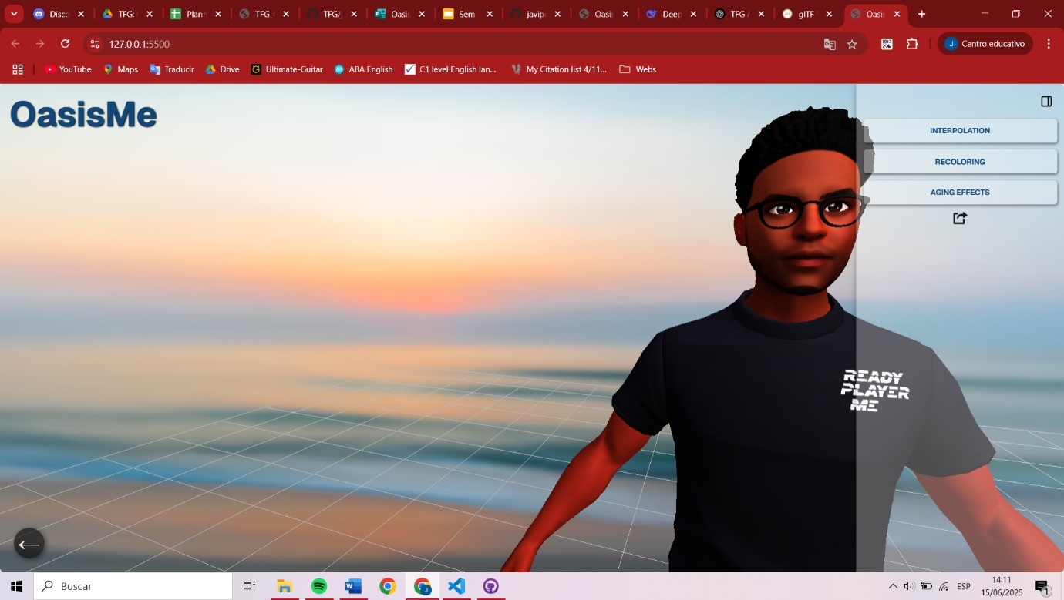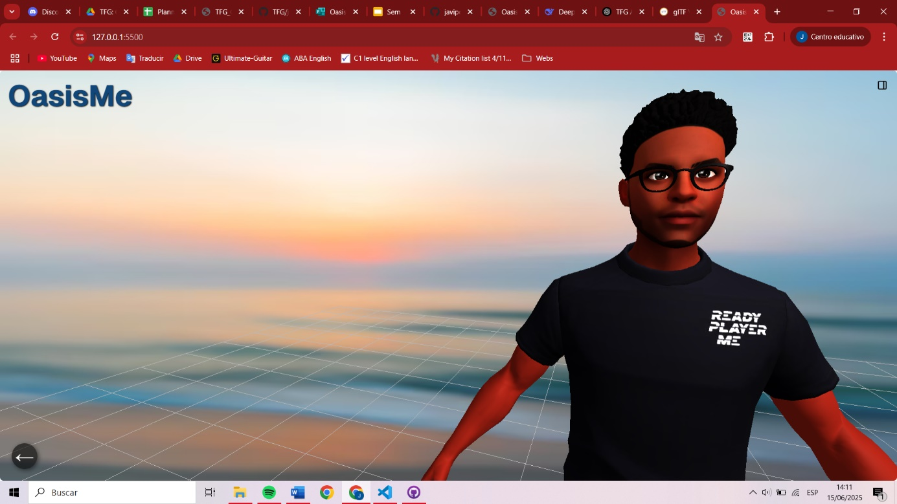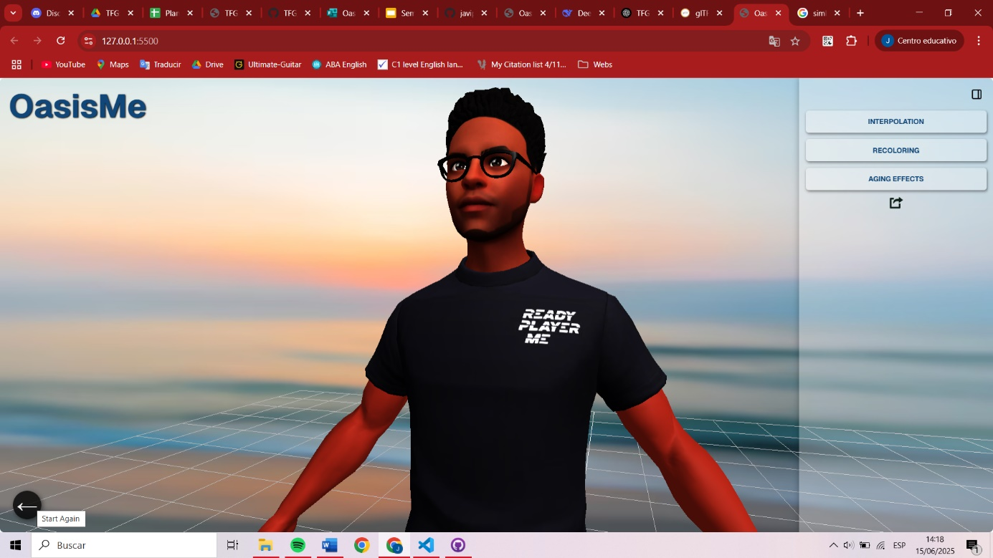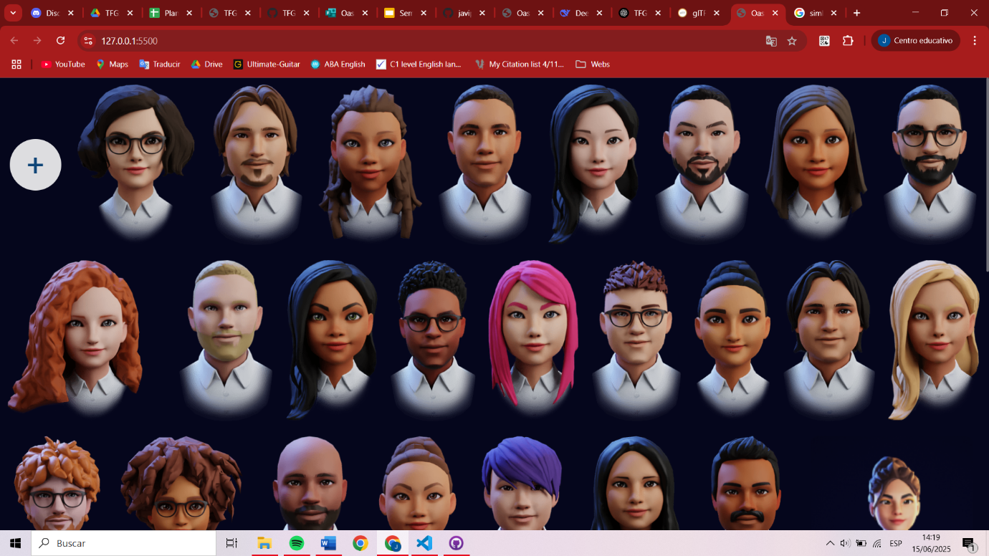

Finally, an “Export Avatar” button, permits to download the avatar in .glb format, which can be open in any tool that enables the visualization of images or graphics in three dimensions.

Likewise, we ensured buttons and panels have consistent styles, margins, and a minimalist color palette for clarity. The result is a simple editor layout: a main 3D view, a right sidebar panel, and obvious controls (back, toggles) with clear labels.

## 6.2 Analysis of Avatar Customization

As seen, the application enables users to personalize a default Ready Player Me avatar through multiple visual modifications. While the technical implementation and overall description were detailed above, this section focuses on demonstrating the visual impact of these customization options through a concrete example.

Let’s consider that the user has chosen the avatar in Figure 6.2 as the source model. Opening the Interpolation section, they can choose three other avatars from a predefined set to serve as interpolation sources. For instance, users can adjust the interpolation panel to define how much of Avatar B’s nose or Avatar C’s jaw should be merged into the current model. These modifications can be seen in Figure 6.5, where the size of the jaw and chin has been increased by blending avatars with these traits, along with other changes.

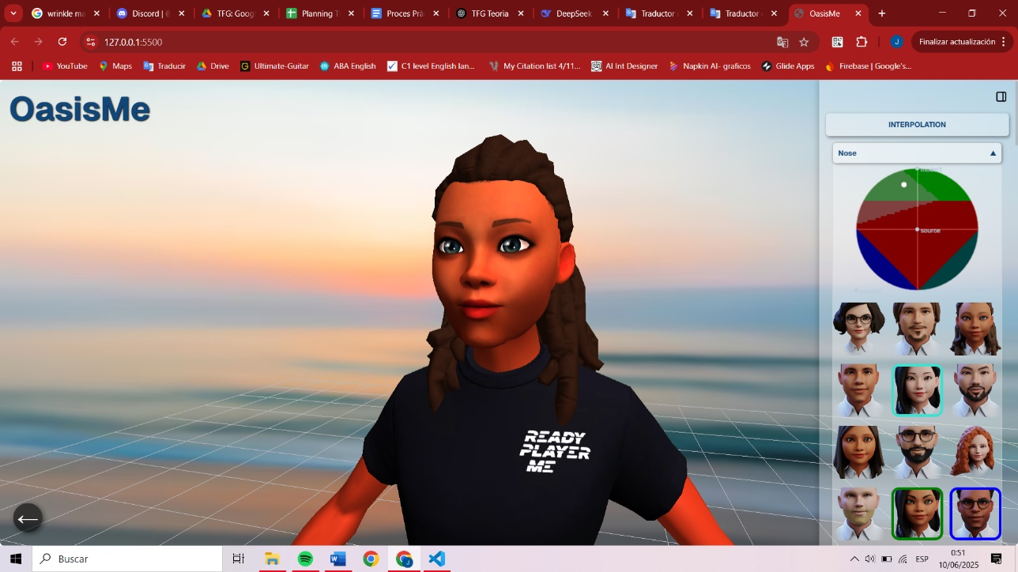

Figure 6.5: Example of an avatar where all the customizable parts were blended with multiple other avatars using the interpolation panel.

In addition to geometry-based modifications, the application also supports texture-level editing through a recoloring system. This system allows users to adjust hair color, skin tone, eye color, and clothing color. All these possible modifications are made to the character in Figure 6.3.

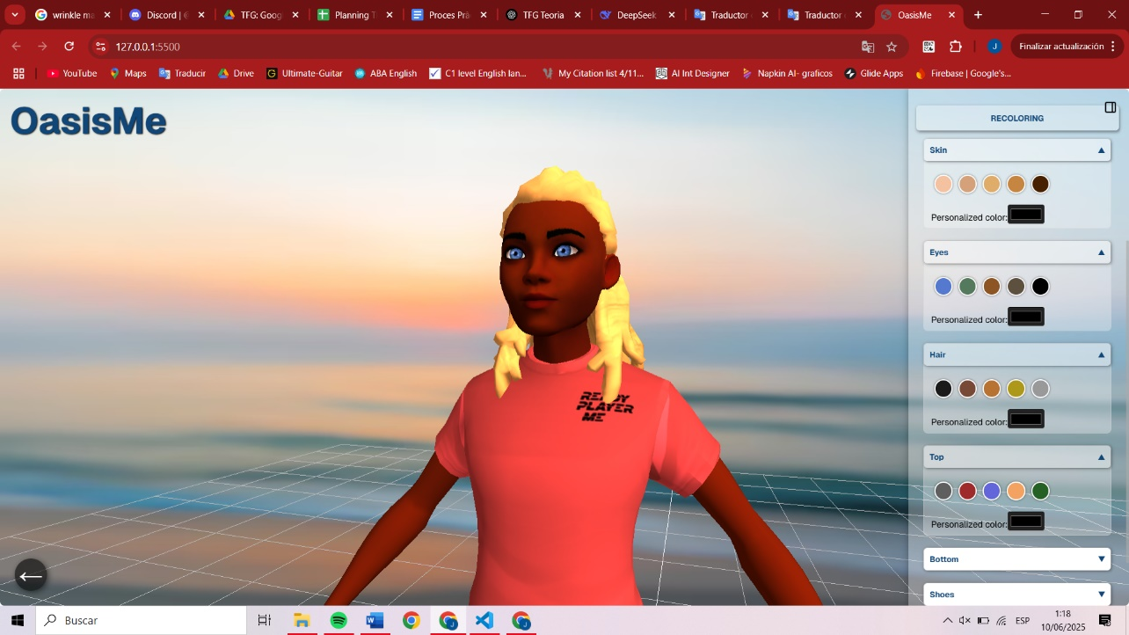

Figure 6.6: Example of recoloring applied to skin tone, hair color, eyes color and clothing color; using the Recoloring section.

Additionally, users can apply aging effects such as wrinkles or grey hair. As shown in Figure 6.7, where these modifications are applied to the original model, presented in 6.2.

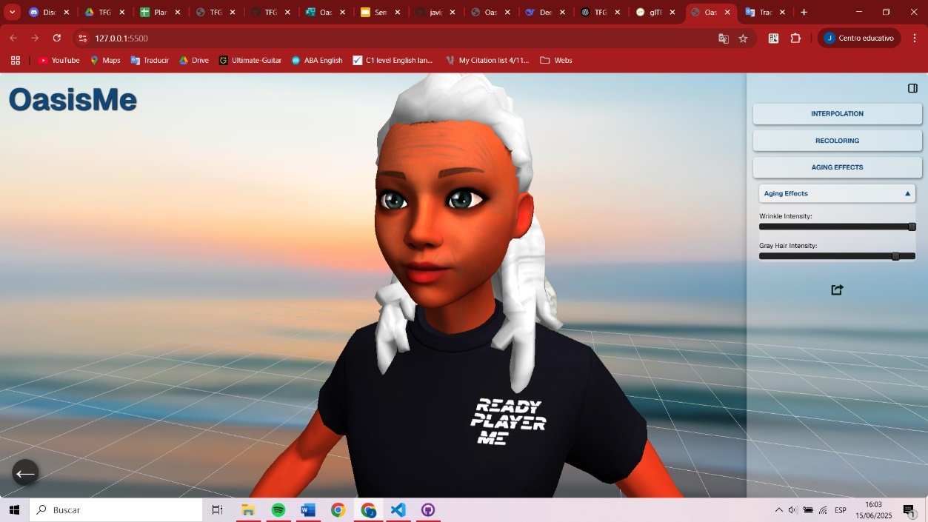

Figure 6.7: Avatar with combined wrinkle overlay and greyscale hair.

Once satisfied, the user can export the avatar in GLB format, preserving the edited geometry and appearance for use in external platforms such as Unity or Unreal. For example, if we had modified the avatar as seen in Figure 6.6, with the recoloring and blending, we could download it pressing the “Export Avatar” button and open the new file in any external platform or 3D viewer[12] like Blender or Autodesk.

Figure 6.8: Final customized avatar exported from the application to glTF Viewer (online 3D viewer).

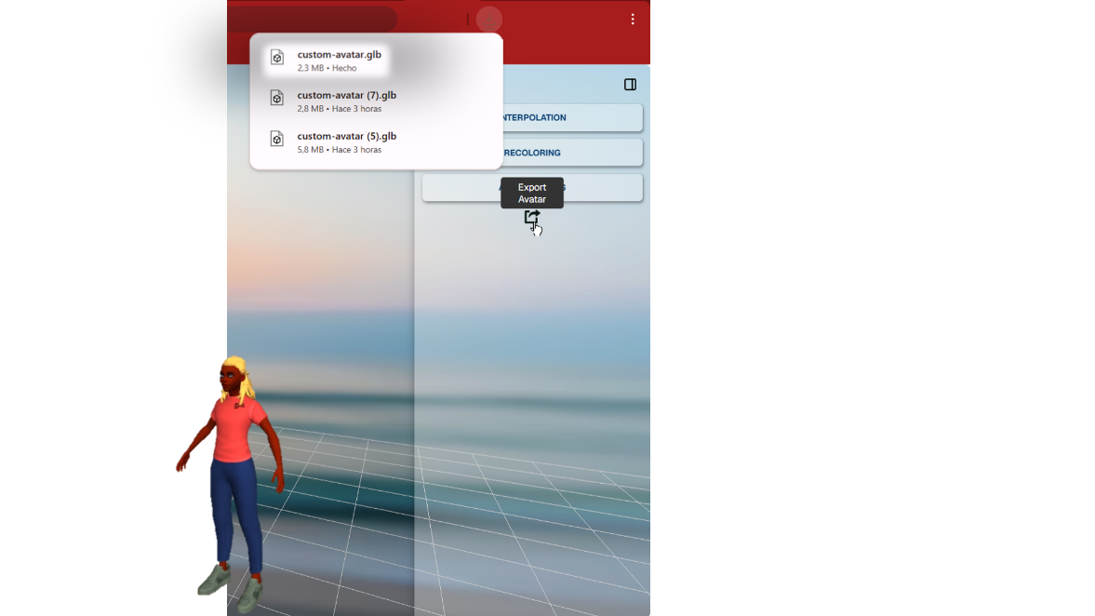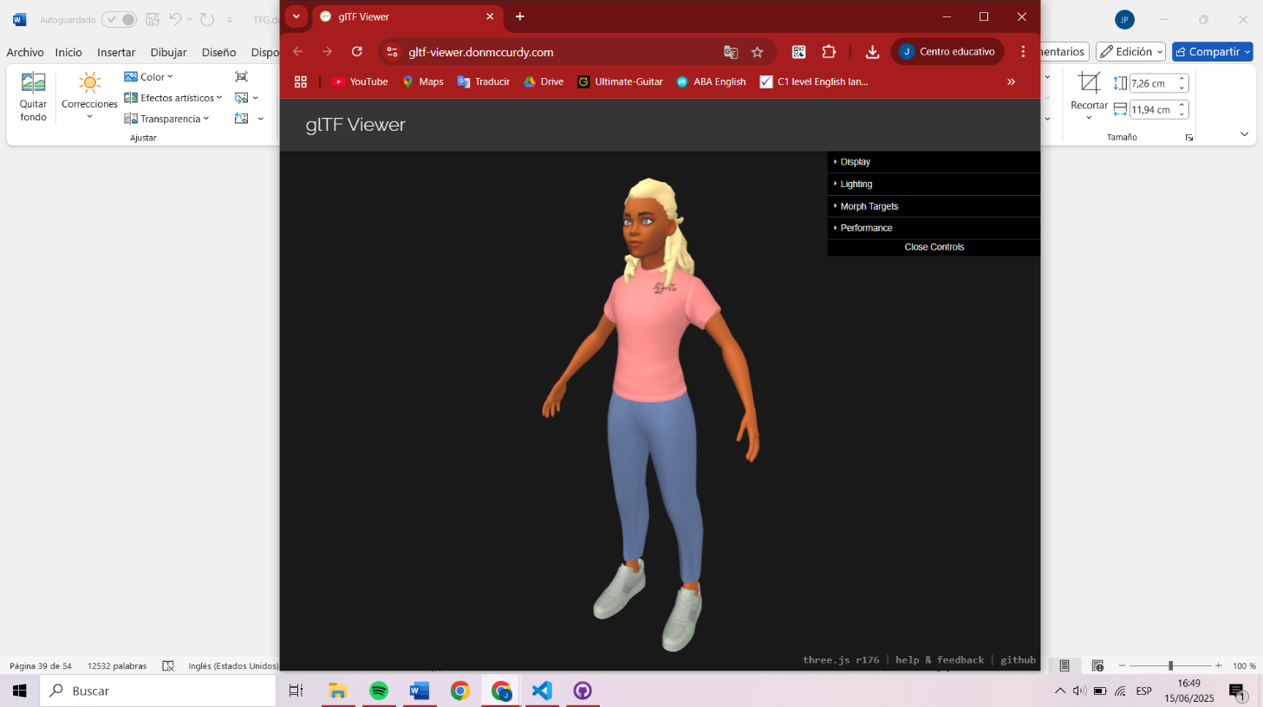

Together, the interpolation, recoloring, and texture blending features offer a very acceptable customization with high-quality results.

## 6.3 User Tests Results

The

**Chapter 7**

# Conclusions

Upon completion, this project successfully achieved its primary goal: to develop a powerful and accessible web-based avatar customization tool. OasisMe stands out by allowing users to create avatars that go beyond generic presets, offering deeper control through features such as interpolating, recoloring, and aging effects. These tools allow for a wide variety of combinations, making it easier for users to create characters that reflect their identity—not only in appearance but also in age, ethnicity, and personal style. Inclusivity was a central focus throughout the development, and the result is a system where people of diverse backgrounds can feel represented. The application is also completely open-source, allowing other developers to build on or adapt the tool to their own needs. User testing revealed high satisfaction; many participants expressed surprise and enthusiasm at the ease with which they were able to design a character that resembled them to some extent.

From a learning perspective, the project represented both a great challenge and an even greater opportunity. Before starting, we had no experience programming in JavaScript or HTML and had to learn the entire ecosystem from scratch, including modern libraries like Three.js and the principles of WebGL and shader manipulation. Additionally, we had very limited knowledge of computer graphics or 3D modeling, which made it an ambitious undertaking. Throughout the process, we developed not only technical skills but also a better understanding of user-centered design and performance optimization for real-time applications. The results, both in functionality and user response, reflect how much we have grown thanks to this experience.

## 7.1 Future Work

There are several directions in which OasisMe could be expanded to improve both customization depth and system flexibility. A key next step would be enabling users to modify broader features of the avatar such as hairstyles and clothing directly through the app. This would give them more freedom to express style and identity, enhancing personal representation even further.

From a technical standpoint, future improvements could include refining the interpolation algorithm. One idea is to allow surrounding vertices near a selected facial region to be interpolated with intermediate weights between the modified area and its static neighbors. This would produce smoother, more natural transitions, especially when editing highly localized features, such as the nose or chin.

Additionally, as the original avatars include their own facial animation morph targets, these could also be interpolated so that the final customized avatar can inherit those facial expressions consistently.

Another improvement would address cases where certain facial structures, such as deep-set eyes, do not blend well. In these cases, adjusting the position of internal elements, such as the eyeball mesh, to follow the deformation would prevent visual issues where the eyes appear to bulge unrealistically.

The interface could also benefit from a more dynamic blending system. For example, the Voronoi Cell could automatically update and re-balance itself based on the number and identity of avatars selected by the user, rather than assuming a fixed configuration.

Finally, expanding compatibility is an important goal. Support for custom .glb models, in addition to those in Ready Player Me, would make the app more versatile and appealing to a broader community of developers and users. This would require adapting the morphing system to work with arbitrary mesh inputs while maintaining a consistent interface and user experience.

# Bibliography

[1]  *Rest api*. Ready Player Me. (n.d.). <https://docs.readyplayer.me/ready-player-me/api-reference/rest-api>

[2] Ayguadé, O. J. (2023). *Development of a Web Platform for the Personalization of Virtual Characters*. TFG. <https://github.com/orioljim1/TFG.git>

[3] Wikipedia contributors. (2025, January 3). *Ready Player One (film)*. Wikipedia. <https://en.wikipedia.org/wiki/Ready_Player_One_(film)>

[4] Schneider, P. (2014, September 26). *NURB Curves: A Guide for the Uninitiated*. MacTech, The journal of Apple technology. <http://preserve.mactech.com/articles/develop/issue_25/schneider.html>

[5] Wikipedia contributors. (2025, March 25). *Voronoi Diagram*. Wikipedia. <https://en.wikipedia.org/wiki/Voronoi_diagram>

[6] Lee, G., Eastman, C. M., Taunk, T., & Ho, C.-H. (2009, October 13). *Usability principles and best practices for the user interface design of Complex 3D architectural design and engineering tools*. International Journal of Human-Computer Studies. <https://www.sciencedirect.com/science/article/pii/S1071581909001451?casa_token=D1hHIZ4bL_kAAAAA%3AaL35Q4IvLVuEKiGL9MkEGbjdlhlKsgZQd7-0Htei4QjZK-ETj6Z-iFM_haQgL21j_cckTtGn>

[7] Prunier, J.-C. (2009). *Welcome to Computer Graphics*. Scratchapixel 4.0, Learn Computer Graphics Programming. <https://www.scratchapixel.com/index.html>

[8]  Bogdan Cosmin Mocanu. 3D mesh morphing. url: <https://theses.hal.science/tel-00836048/file/ThA_se_MocanuBogdan.pdf>. Institut National des Télécommunications, 2012. English.

[9]  Klaus Engel, Markus Hadwiger, Joe Kniss, Christof Rezk-Salama, Daniel Weiskopf: Real-Time Volume Graphics, A K Peters, 2006. <https://dl.acm.org/doi/pdf/10.1145/1103900.1103929>

[10] N. K. Jayakodi, J. Rao Doppa and P. P. Pande, "PETNet: Polycount and Energy Trade-off Deep Networks for Producing 3D Objects from Images," *2020 57th ACM/IEEE Design Automation Conference (DAC)*, San Francisco, CA, USA, 2020, pp. 1-6, doi: 10.1109/DAC18072.2020.9218525.

[11] *Three.js*. three.js manual. (n.d.). <https://threejs.org/manual/#en/fundamentals>

[12]  Blender 4.3 Manual. (n.d.). <https://docs.blender.org/manual/en/latest/>

[13] Rodríguez, A., & Valls, E. (2025). lexgui.jsVersion (0.6.3). *LexGUI Docs*. Retrieved May 2025, from <https://jxarco.github.io/lexgui.js/>.

[15] Javi Agenjo. litegui.js. url: <https://github.com/jagenjo/litegui.js>.

[14] Metahuman | realistic person creator - unreal engine. (n.d.). <https://www.unrealengine.com/en-US/metahuman>

[15] Exocortex Technologies, Inc. (n.d.). *The scene list*. Clara.io. <https://clara.io/learn/user-guide/basics/list>

[16] 3Dsf.info. (2025, April 4). Tinkercad drawbacks. <https://sites.google.com/site/3dsfinfo/tinkercad-review/tinkercad-drawbacks>

[17] Ginier, S. (2020). *Homepage*. Stéphane GINIER. <https://stephaneginier.com/>

[18] Paramvir. (2013, December 26). *Discussions on Indian advertising creative*. SculptGL : Web based sculpting tool. <https://www.desicreative.com/forum/viewtopic.php?t=8771#:~:text=It%20features%20dynamic%20and%20adaptive,holes%20and%20merges>

[19] Kuppens, J. (2023, April 19). *WebGL morph targets and ginger: Modernizing for today’s web*. This Dot Labs. <https://www.thisdot.co/blog/webgl-morph-targets-and-ginger-modernizing-for-todays-web>

[20] Adobe Systems Incorporated. (n.d.). Mixamo. <https://www.mixamo.com/#/>

[21] DAZ Productions, Inc. (n.d.-b). *About Us*. Daz 3D. <https://www.daz3d.com/about-us>

[22] pixiv. (n.d.). *Vroid Studio*. VRoid. <https://vroid.com/en/studio>

[23] *Studio (Developer Dashboard)*. Ready Player Me. (n.d.).  <https://docs.readyplayer.me/ready-player-me/customizing-guides/studio-developer-dashboard>

IMAGES:

Figure 2.1: <https://codepen.io/rachsmith/post/beginning-with-3d-webgl-pt-2-geometry>

Figure 2.2: <https://cgifurniture.com/blog/3d-modeling-texture-resources/>

Figure 2.3: RPM UV map used in the project

Figure 2.4: Done by my own with blender

Figure 3.1: <https://www.norwegiancreations.com/2015/10/a-quick-look-at-autodesk-tinkercad/>

Figure 3.2: <https://stephaneginier.com/>

Figure 3.3: <https://clara.io/learn/user-guide/basics/interface_overview>

Figure 3.4: <https://es.digitaltrends.com/noticias/metahuman-creator-descargar-requisitos-epic-games/>

Figure 3.5: Screenshot

Figure 3.6: <https://x.com/jackdbrody/status/1681680555639996416>

Figure 3.7: <https://assetstore.unity.com/packages/tools/integration/meta-avatars-sdk-271958>

Figure 3.8: <https://wii.fandom.com/wiki/Mii>

Figure 3.9: <https://www.thisdot.co/blog/webgl-morph-targets-and-ginger-modernizing-for-todays-web> or [18]

Figures 4.1 – 4.5: Screenshots or by my own

Figure 5.1: Screenshot

Figure 6.1: Screenshot

# Appendix

## A. User Flow Diagram

The user flow is the general outline that represents the possible paths a user can take within the application. It helps visualize and understand how users interact with the interface, from the moment they access the platform to the moment they reach their goal which, in this case, is downloading the customized avatar.

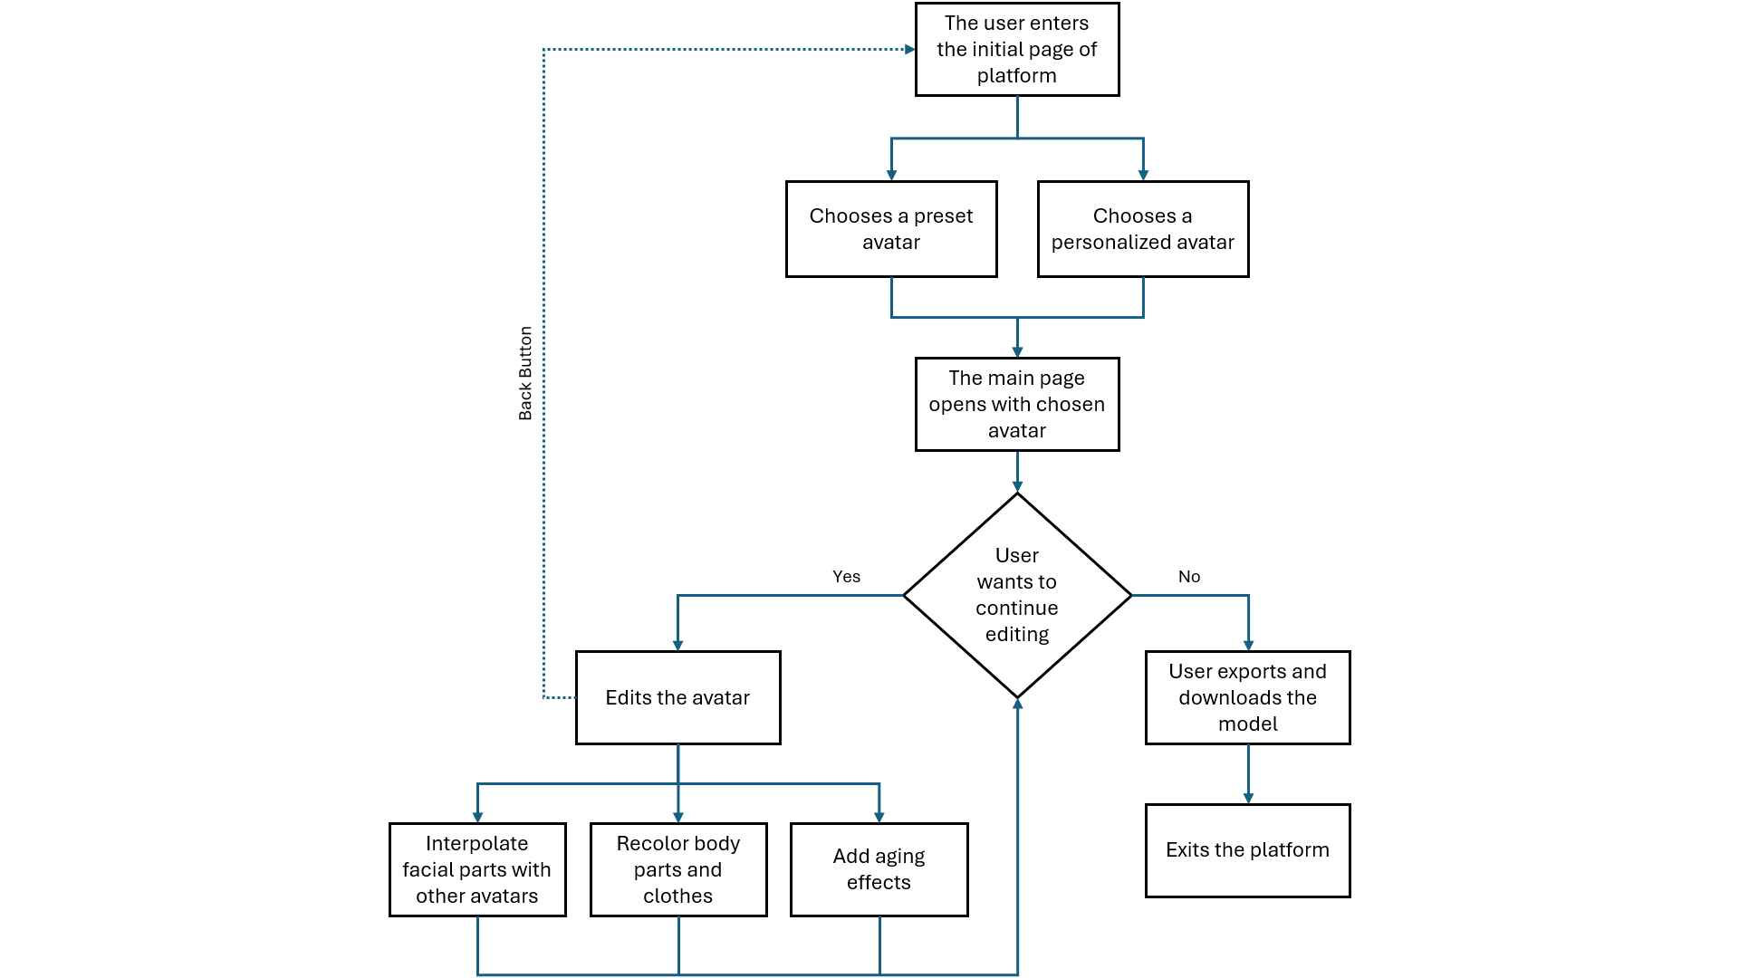The representation of this can be seen in Figure A.1:

Figure A.1: User Flow of OasisMe

**B. Questionnaire**

In order to retrieve feedback about the usability of the platform, a questionnaire was given to a group of 15 users. The only prompt was to customize an avatar as they wanted. After the completion of this process, they were asked to complete the questionnaire shown below. The answers were collected in an Excel directly from the Microsoft Forms page, to extract statistical information.

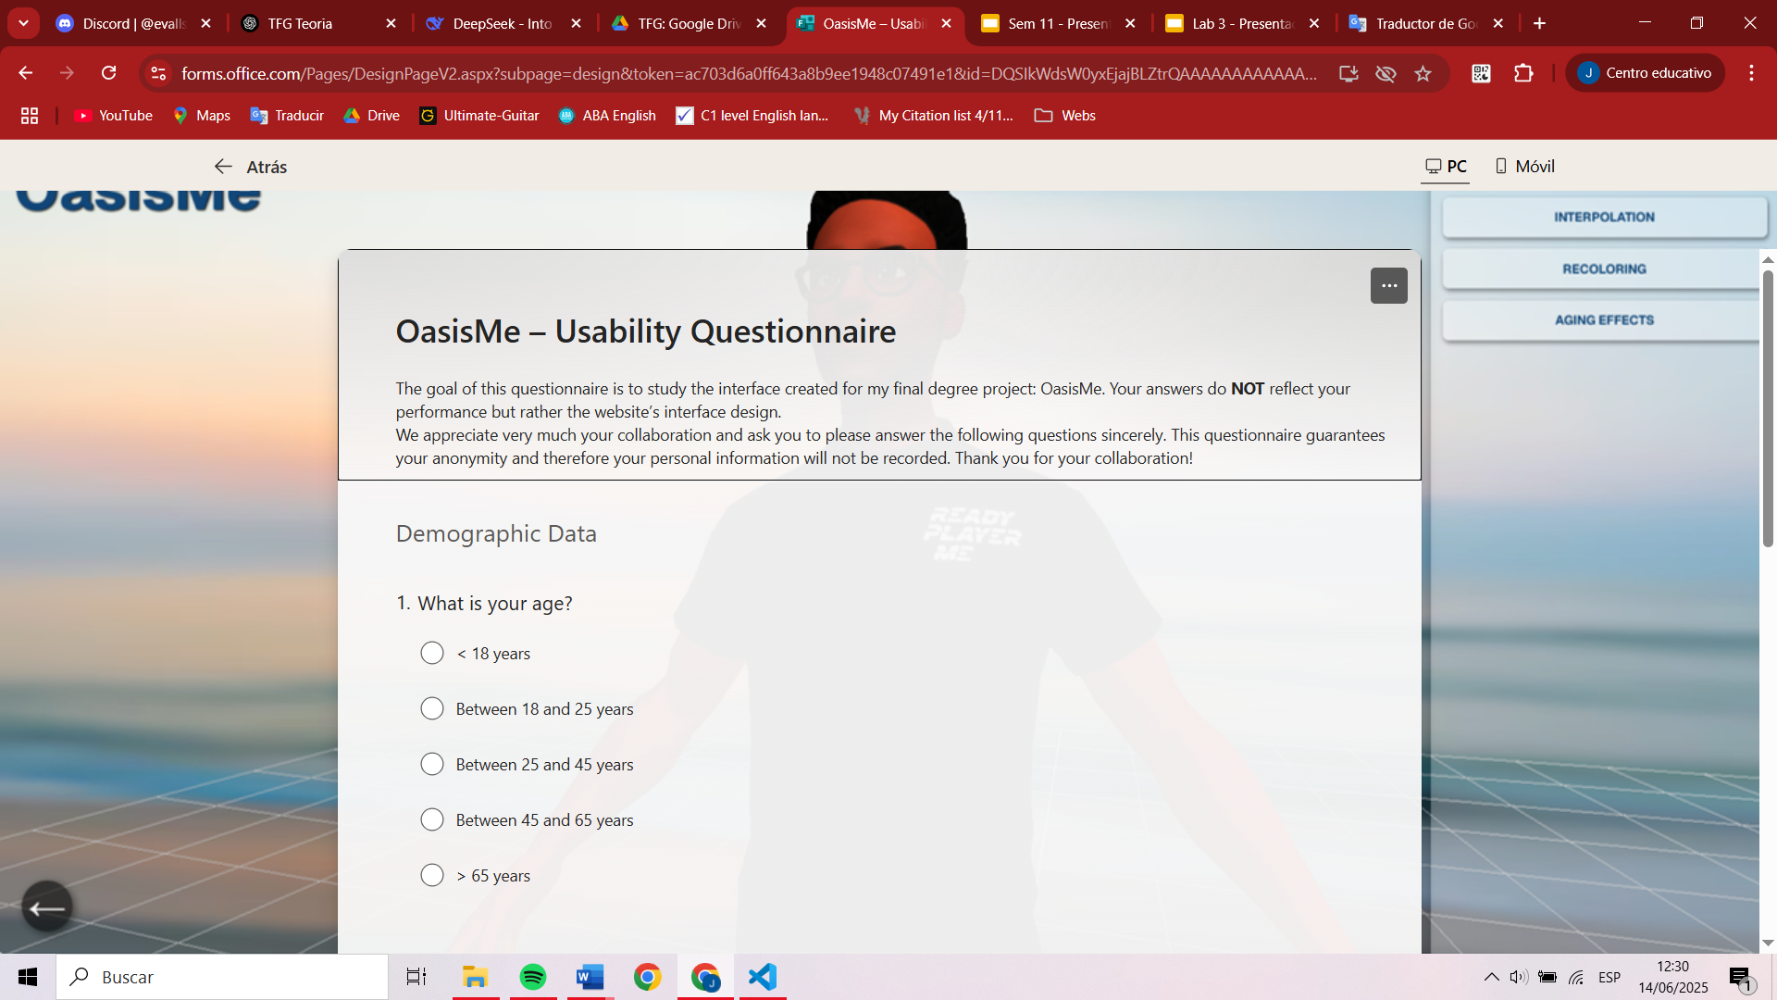

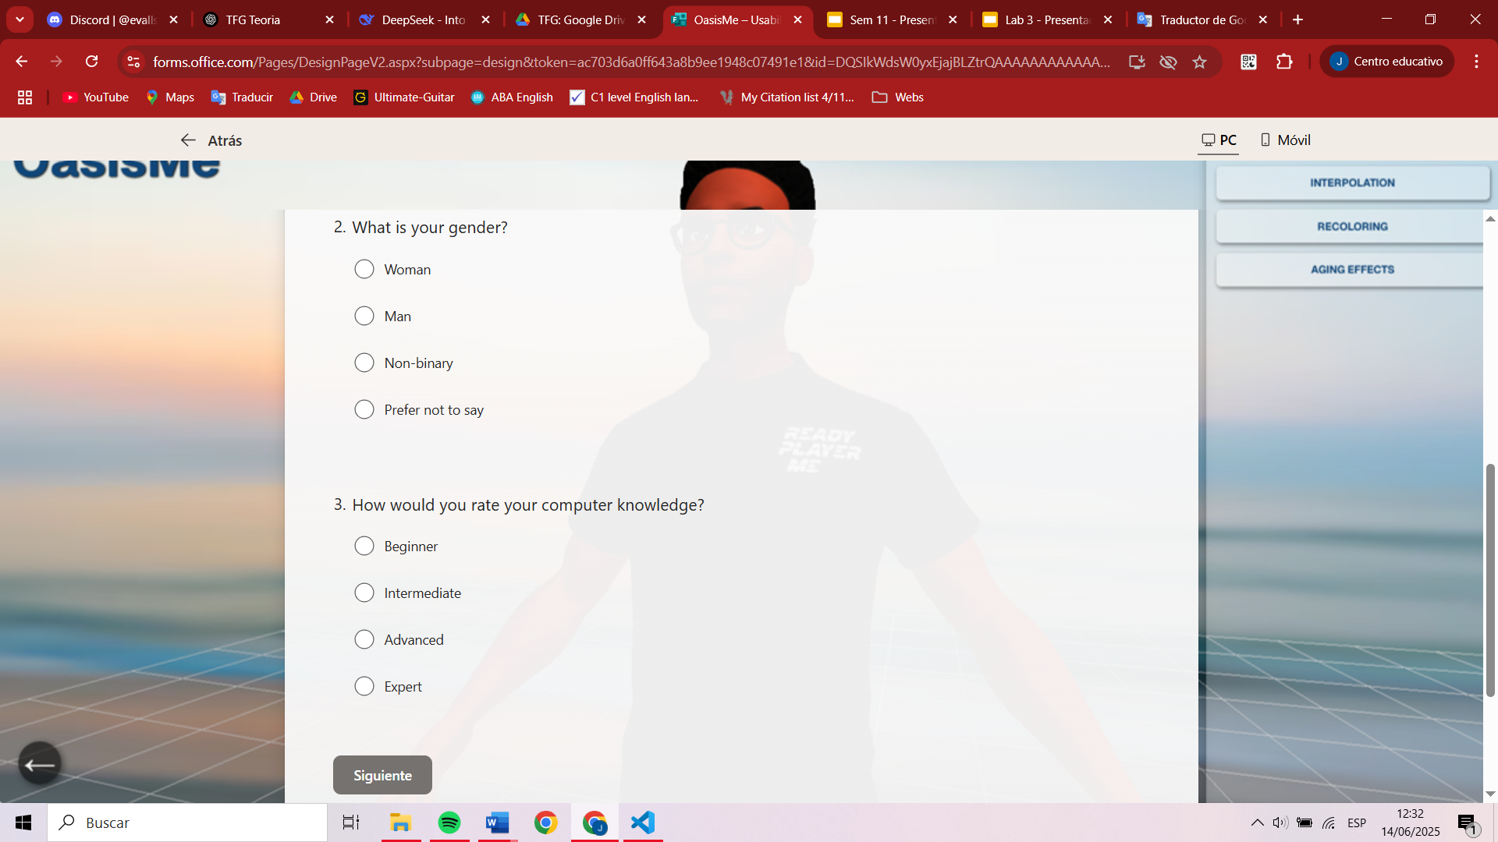

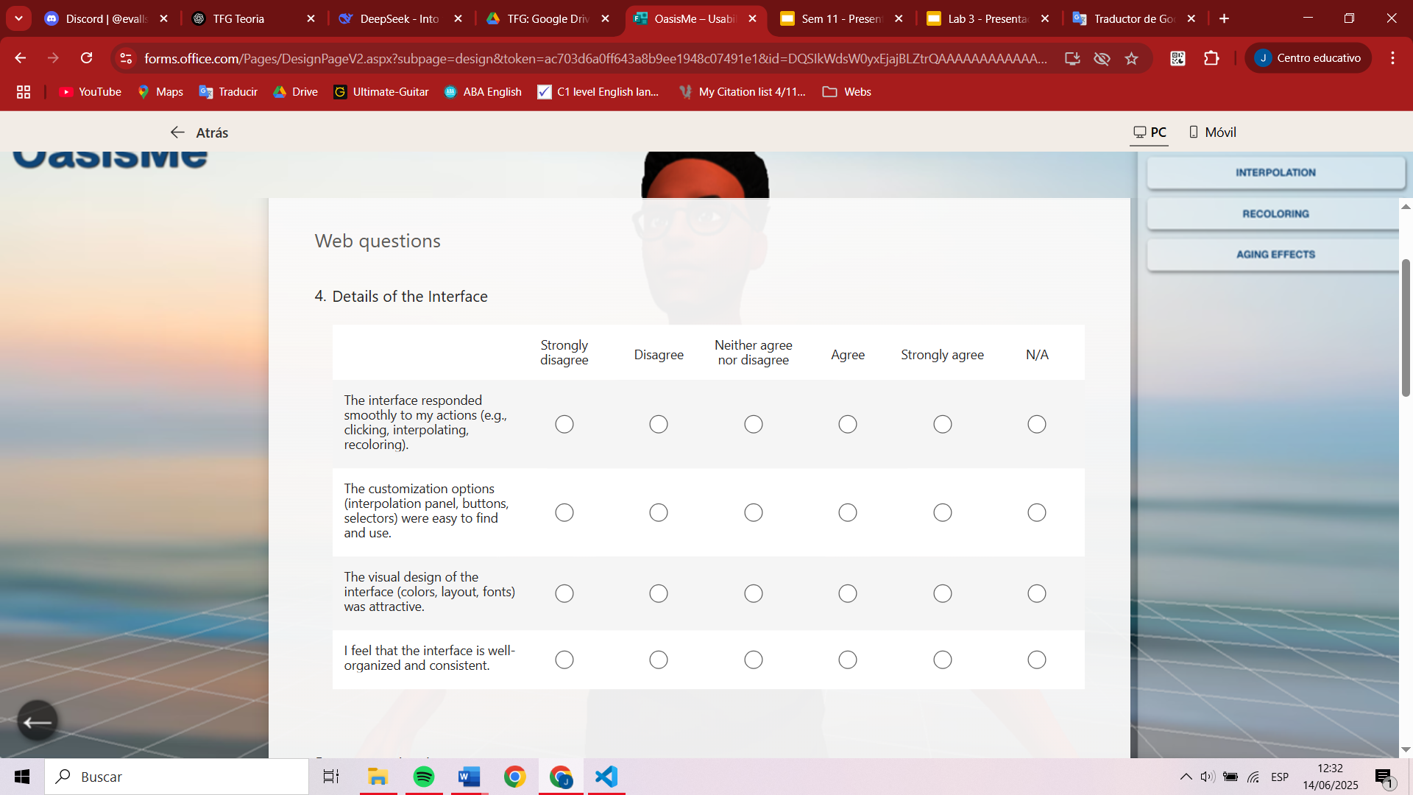

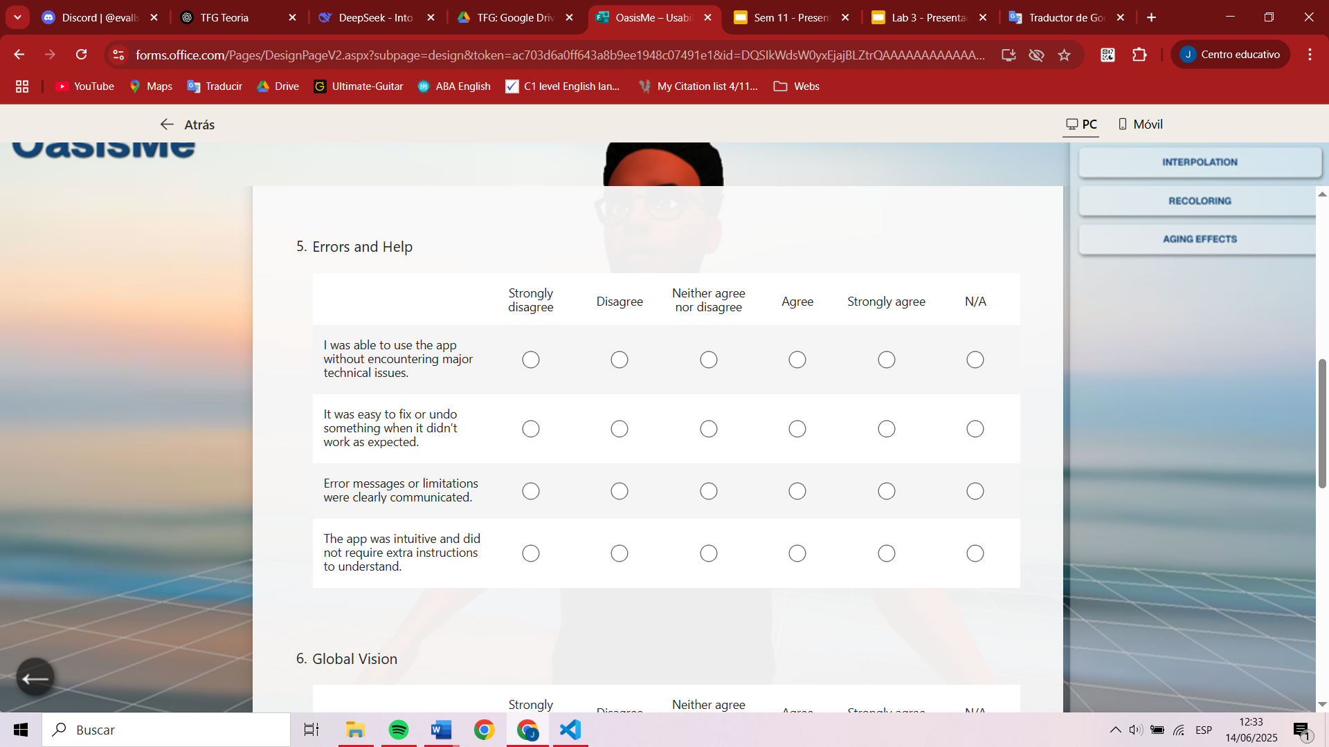

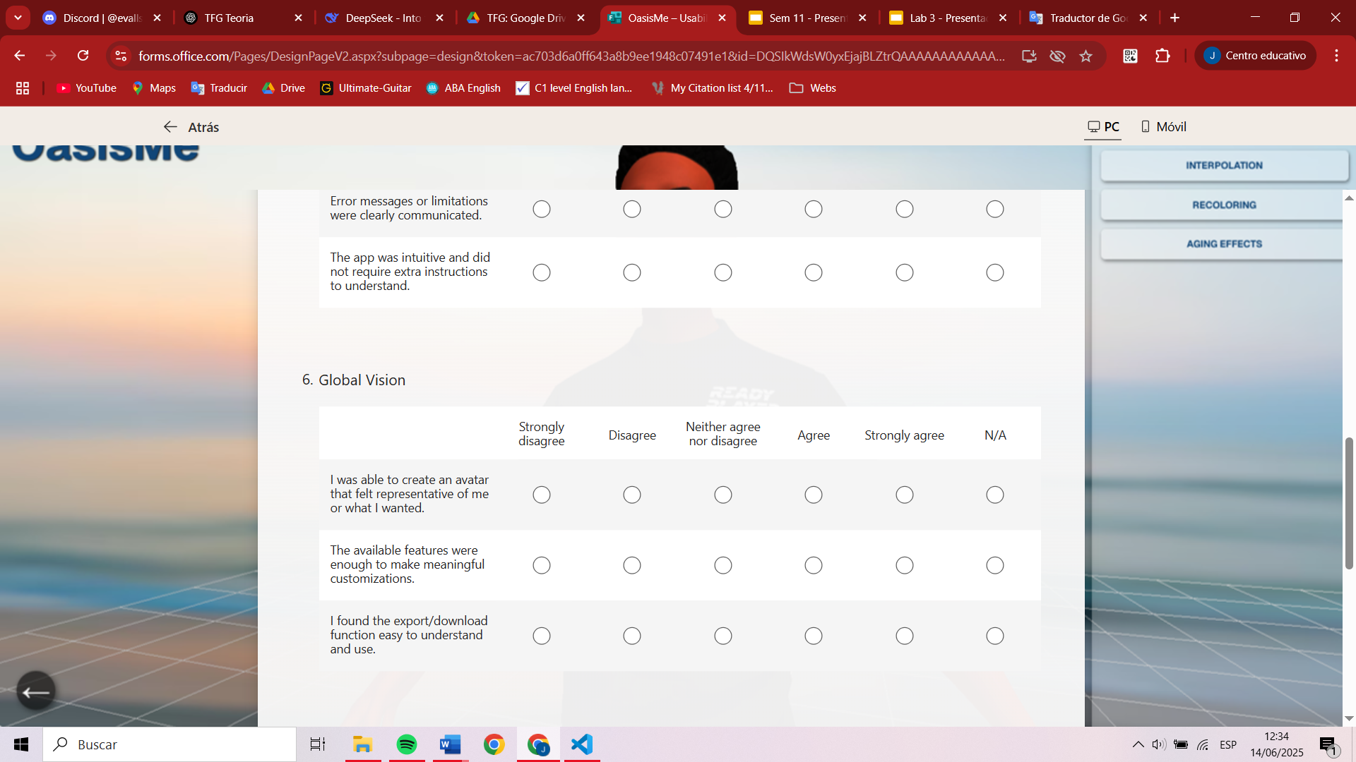

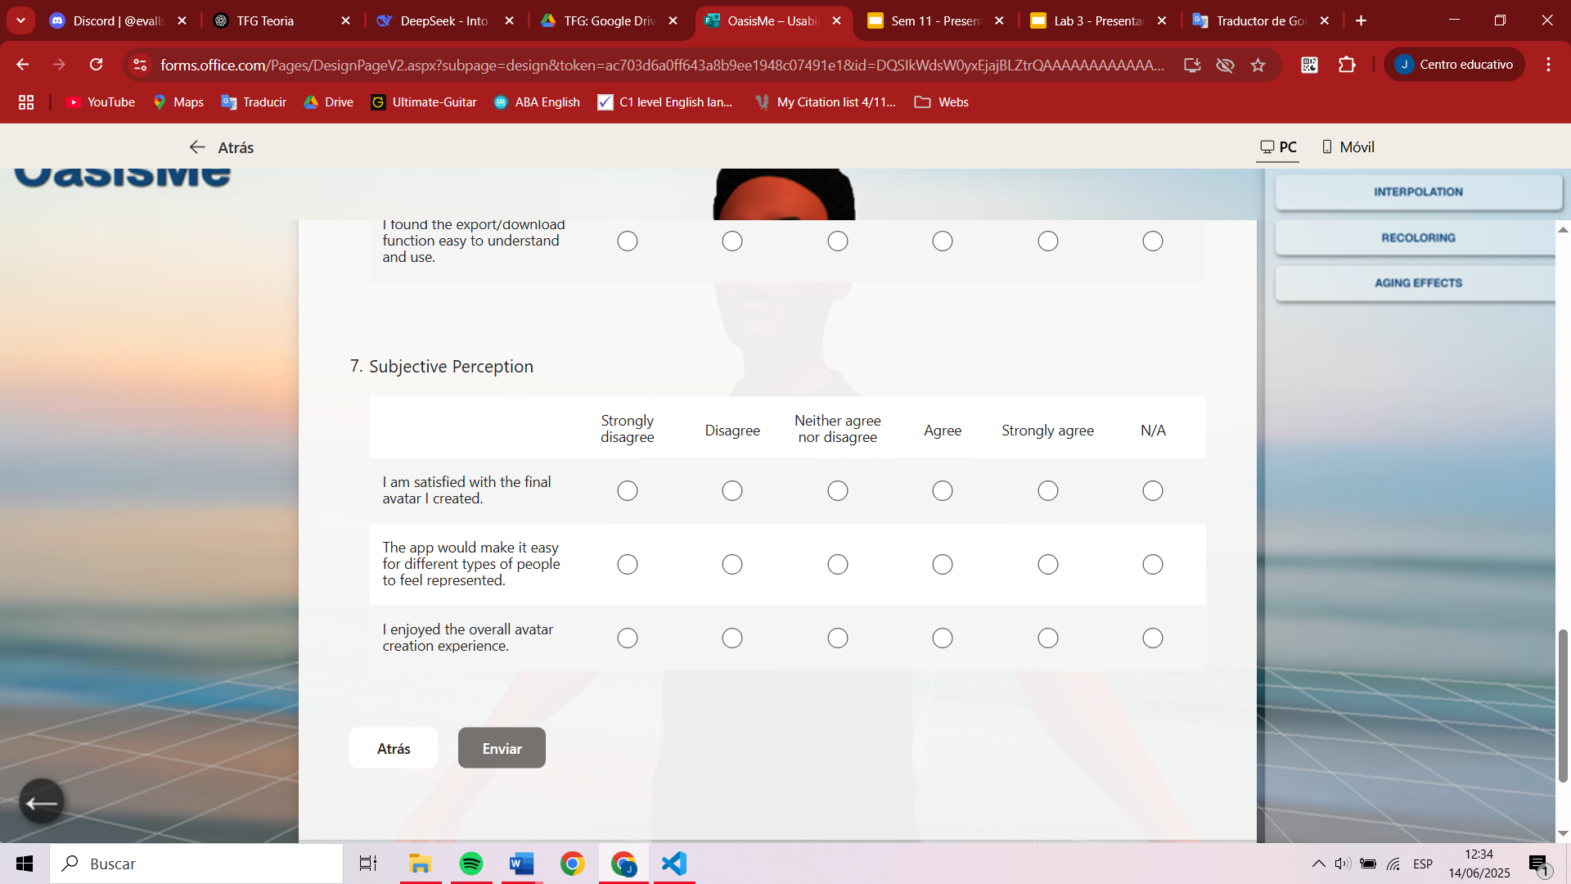

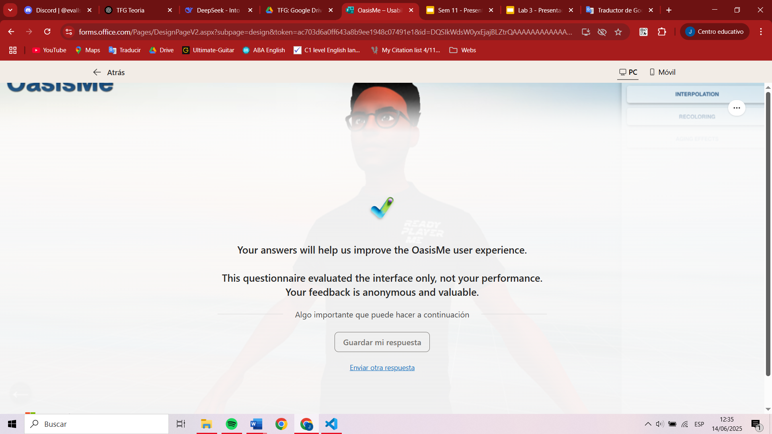

Then we extracted the statistics from this questionnaire:

## C. Selection of vertex sets

Sets of vertices were selected in Blender to save their indexes and be able to modify their positions if the user decides to interpolate that part of the face. All the captures of these selections are shown below, from Figure C.1 to Figure C.5.

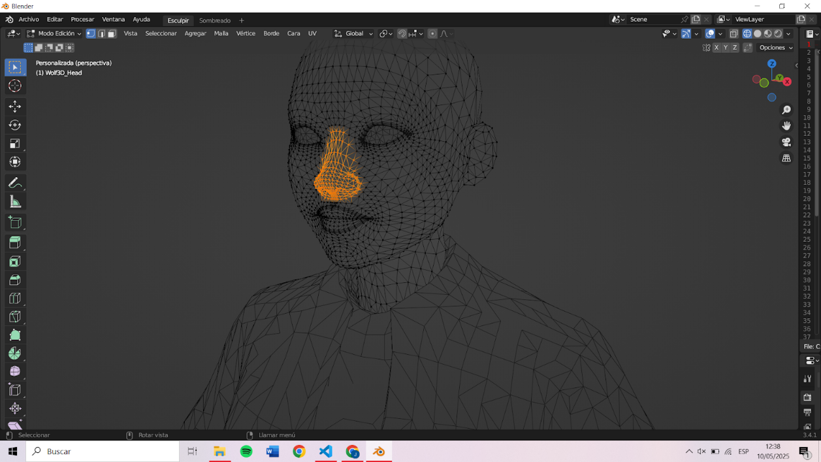

Figure C.1: Selection of the vertices of the nose

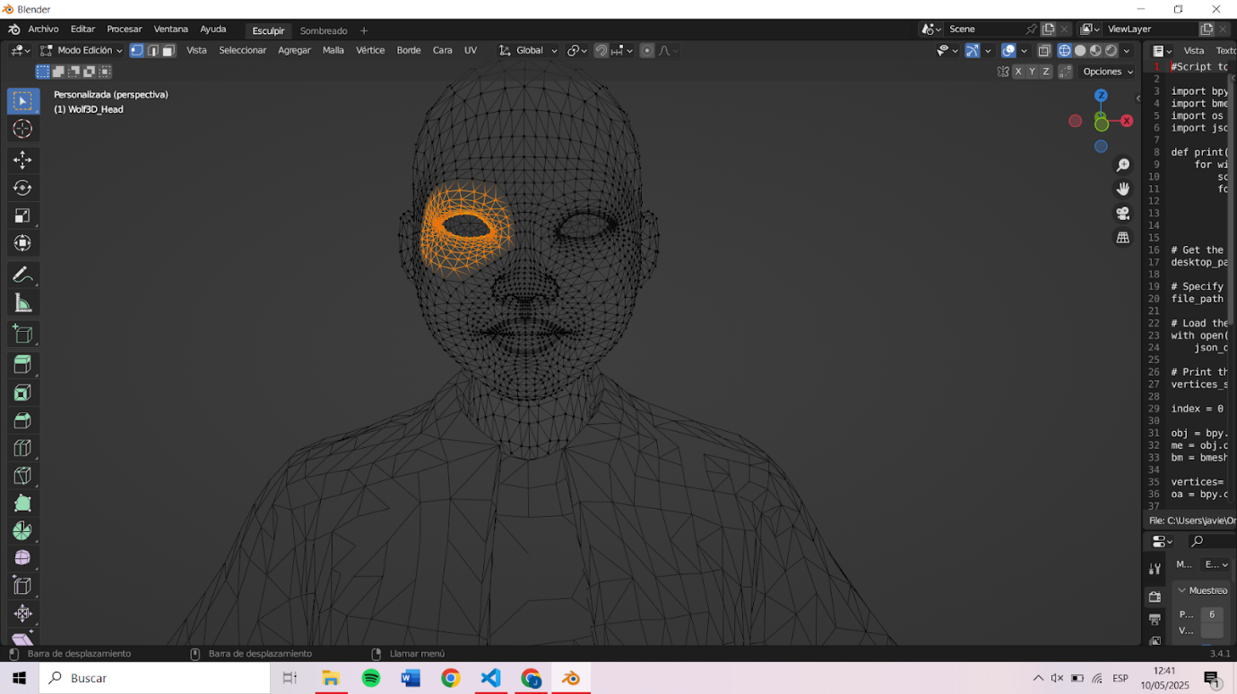

Figure C.2: Selection of the vertices of the right eye

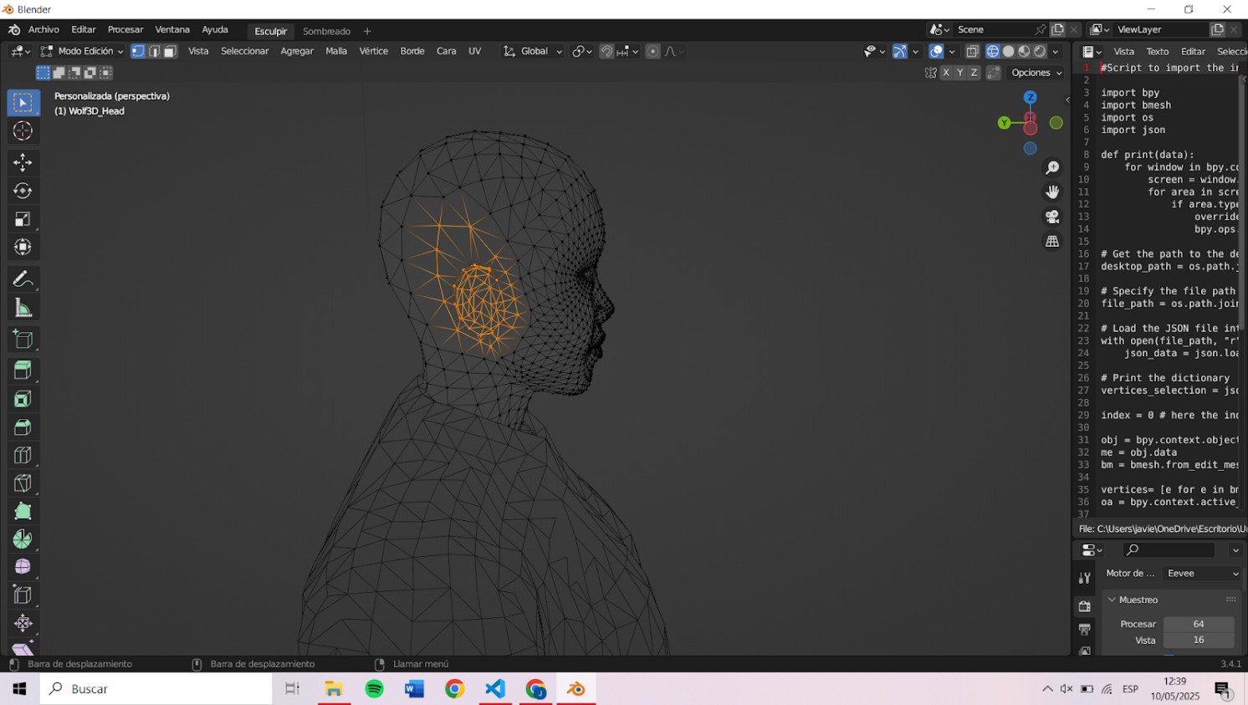

Figure C.3: Selection of the vertices of the right ear

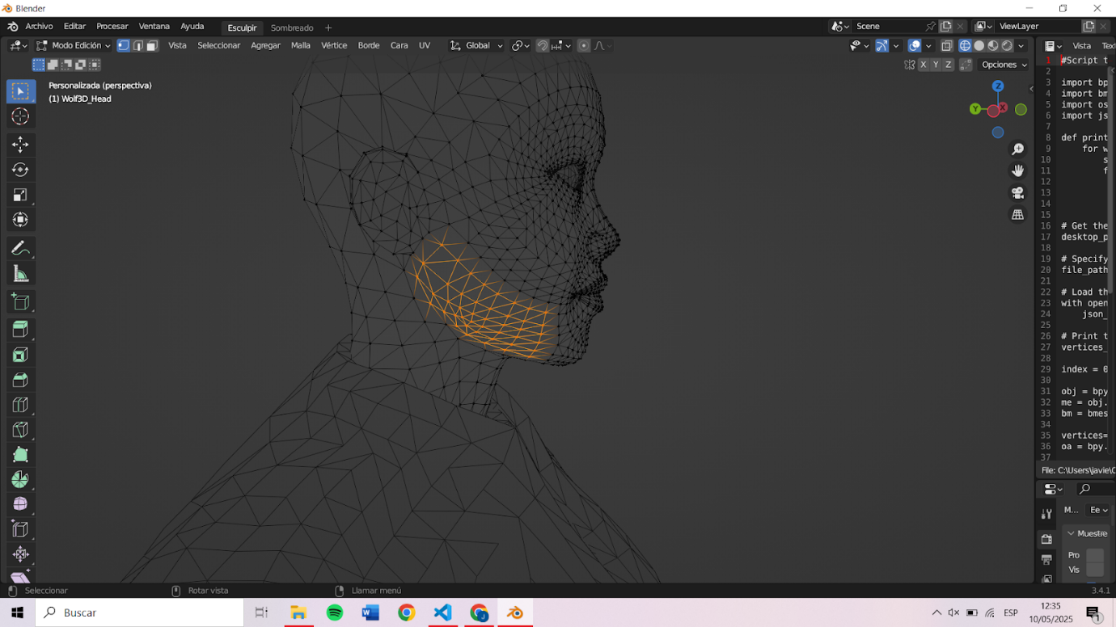

Figure C.4: Selection of the vertices of the right side of the jaw

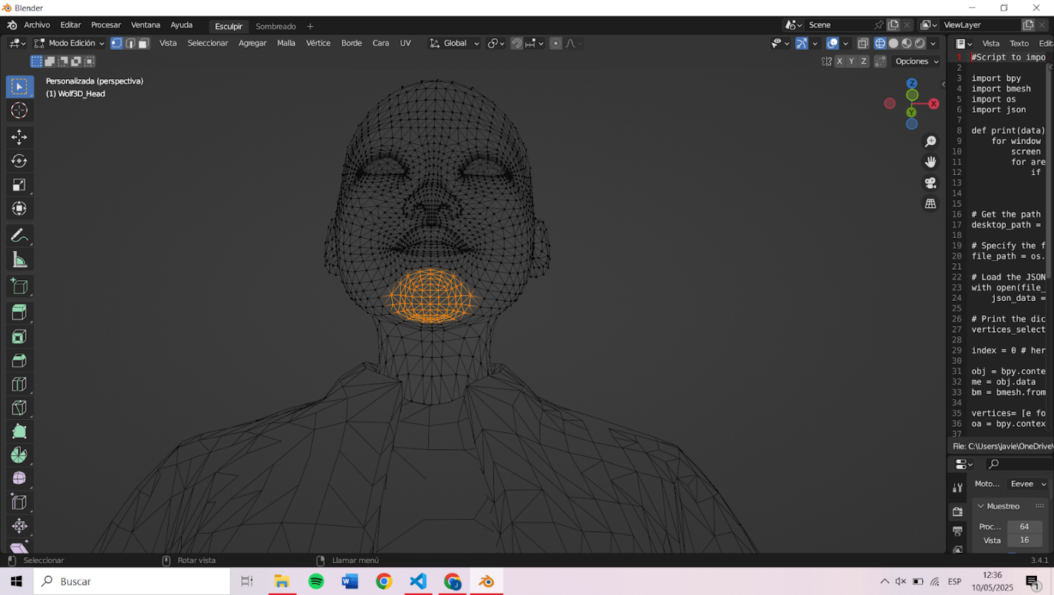

Figure C.5: Selection of the vertices of the chin

## D. Implementation Planning

A Google Sheets template was developed as a task calendar to organize the project into clear stages, assigning realistic deadlines and prioritizing dependencies between activities. The template included columns for tasks, task status (not started, in progress, or completed), expected completion dates, and notes, if necessary. This gave me a comprehensive view of the project's progress throughout its implementation.

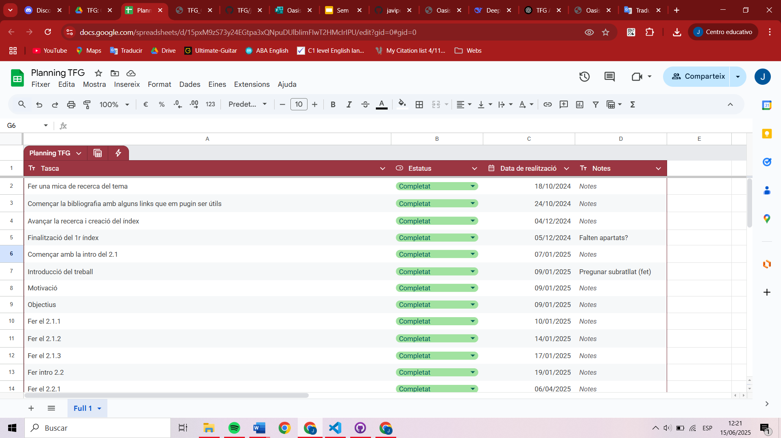

Figure D.1: Task calendar of the first steps of the project

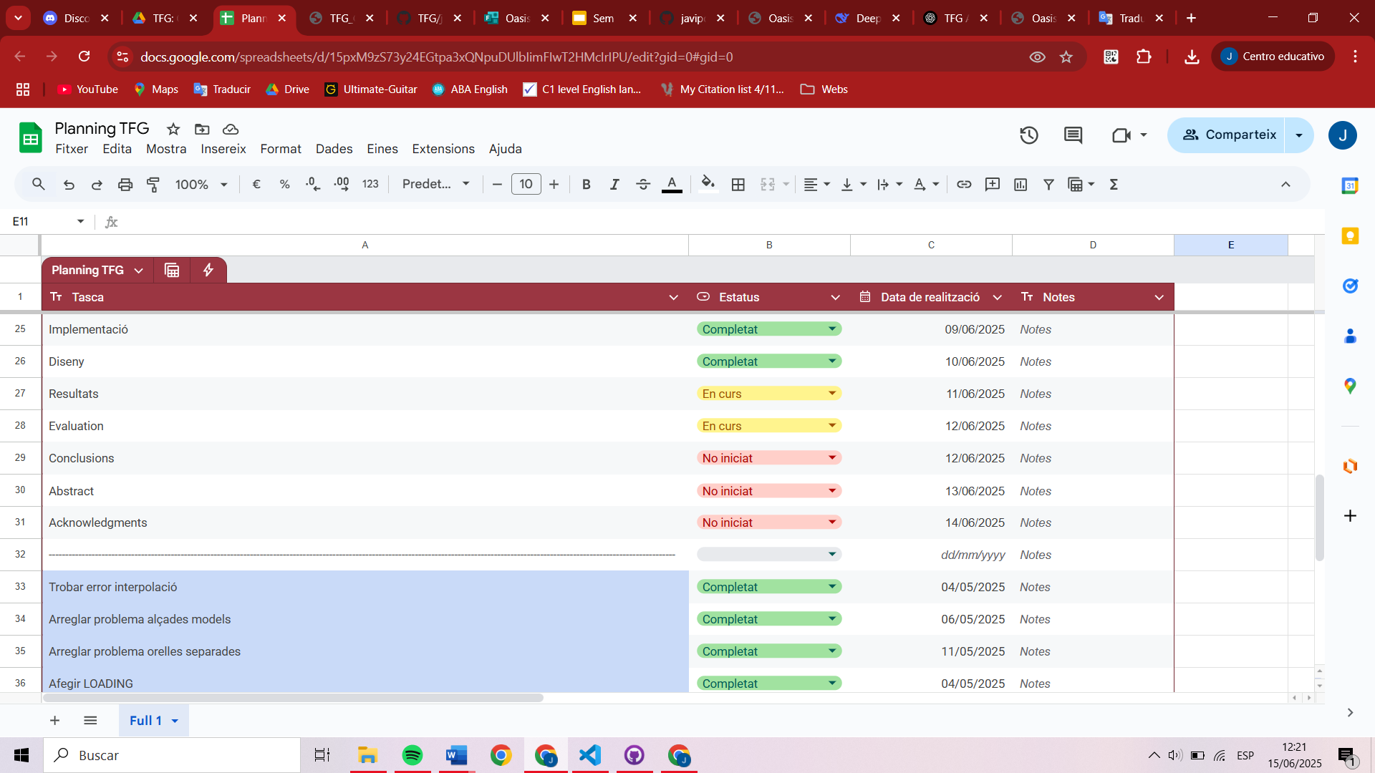

Figure D.2: Task calendar with some theoretical and implementation steps

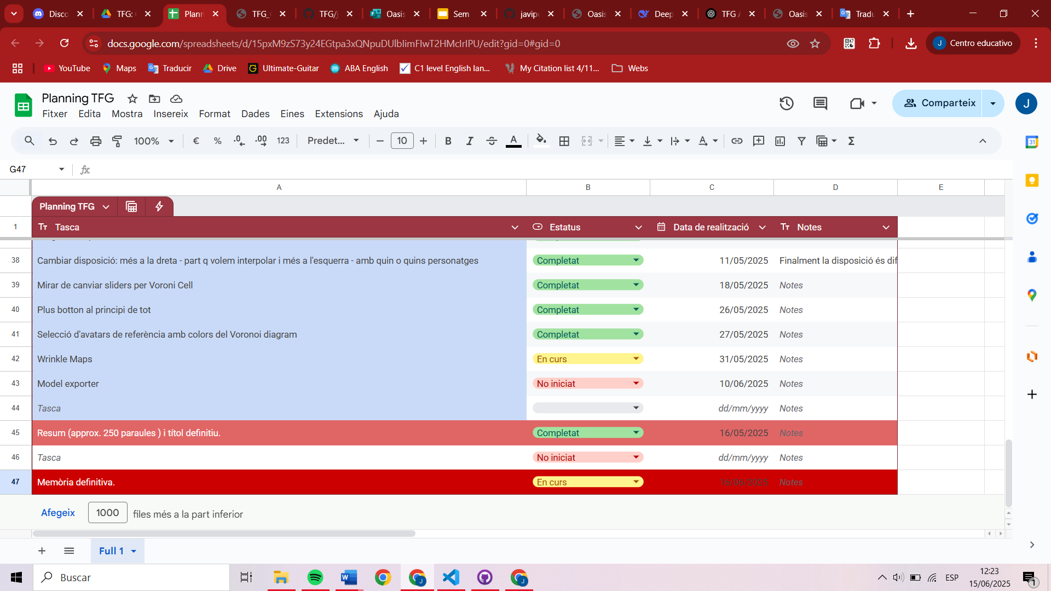

Figure D.3: Task calendar with the last steps of the project

1. NURBS patches: NURBS patches are individual segments or portions of a surface that are defined by a NURBS model (Non-Uniform Rational B-Splines). These patches are used to create complex 3D shapes by combining multiple smaller NURBS patches together. [4]
2. WebGL (Web Graphics Library) is a JavaScript API that allows rendering 3D and 2D graphics within a web browser without the need for additional plugins.
3. A tool provided by Epic Games that acts as a content manager. It allows users to easily import 3D assets (including MetaHumans) into Unreal Engine (UE).
4. Software Development Kits are pre-made packages of code and tools that make it easier to add certain features (in this case, RPM avatars) without building everything from scratch.
5. Fortnite is a battle royale game developed by Epic Games, released in 2017.
6. Litegui[15] is a Javascript library to create webapps with a desktop look-alike interface. All the widgets are created from Javascript instead of using HTML.
7. LexGUI [12] is a lightweight graphical user interface library used for real-time control of parameters in web-based 3D applications.
8. A Voronoi cell is a region around a point (called a seed) that contains all the nearby positions closer to that point than to any other. When you place several seeds on a plane, the space is divided so that each area belongs to the closest seed — this division is called a Voronoi diagram. [5]
9. Blender [11] is an open-source 3D creation suite. It supports the entirety of the 3D pipeline: modeling, animation, rendering, among many other utilities. It is a very powerful tool and is used in the animation, video game and visual effects industries.
10. Python is a high-level programming language widely used in web applications, software development, data science, and machine learning (ML).
11. The Three.js docs[11] explain: “Interleaved’ means that multiple attributes, possibly of different types, (e.g., position, normal, uv, color) are packed into a single array buffer.” The stride is the number of array elements per vertex. For example, if position (3 floats) and normal (3 floats) are interleaved, the stride is 6.
12. A 3D viewer is a tool or application that allows users to view models in three dimensions, allowing them to interact with them from different angles and depths.